
PRODUCTION BIBLE

LAST REVIEW (ALWAYS UPDATE): 24.12.2023.





PLEASE NOTE

This document is for internal use only. The contents in this document are solely for discussion-purposes, and therefore may not be distributed to any 3rd parties, client-partners or external suppliers. Concepts and briefing materials as supplied by the client remain the intellectual property of the client. Concept, ideas, themes and/or other creative materials written, developed or otherwise authored by „DIGI.BA“ and “SSST” as presented in this document remain Intellectual Property of „DIGI.BA“ and “SSST”

Introduction

This is a living document detailing the production-process for the SHELeadersVR project.
Each of the next sections provides an overview of that element’s role in the production, what needs to be done, when it needs to be done, by whom, and according to which specifications.

TABLE OF CONTENTS

Introduction 2
VR Application overview 5
VR Application design 5
Intro menu 5
UI design 6
Intro cinematic 10
Starting room 11
Final room 13
Custom controllers 15
Section design 17
Bosnia and Herzegovina 18
Serbia 22
North Macedonia 23
Albania 27
Montenegro 30
Actress filming on Chroma key 34
Bosnia and Herzegovina VR scenario 34
Bosnia and Herzegovina AR scenario 35
Serbia VR scenario 35
Serbia AR scenario 36
North Macedonia VR scenario 36
North Macedonia AR scenario 37
Albania VR scenario 37
Albania AR scenario 38
Montenegro VR scenario 39
Montenegro AR scenario 40
360° Videos field recording 40
Makeup section 40
Costume section 40
Technical section 46
3D modelling of main components 47
3D modelling of additional items 49
Keying of videos 49
Editing of videos 49
Compositing of videos 49
Audio postproduction of videos 50
Music composing 50
Sound effects design 51
Programming 51
Storytelling part of programming 52
Subtitles in Unity 52
Gameplay part of programming 52
UX programming 53
Additional programming 54
Crowd simulation system 54
AR Application overview 55
AR Application design 55
The Wireframe 55
UI design 57
AR Application build 63

VR Application overview

Application that will be created for the SHELeadersVR project is Virtual Reality application for Meta Quest headsets. It will be a combination of 360 videos with a superimposed actress narrator who will tell stories about selected queens in Balkans from mediaeval times, and 3D modelled environments through which the user will be able to move and explore. These gameplay parts of the application will have quests which the user will need to solve as well as questions from stories told in narrated parts of the application. The user will get reward for each solved gameplay and when all rewards are collected, congratulations message will be displayed and the final gameplay environment unlocked where all 3D models will be displayed for reviewing.

VR Application design

Intro menu

Intro menu needs to be designed as a 360 photo which will load when the application is run. There will be flags to choose the language of the application. After choosing language buttons will appear in front of the user. “PLAY”; “EXIT”; “HELP”. Pressing “HELP” will open a picture of the 2 controllers with each button explaining what it does. Pressing “PLAY” will run the application with screen fading to black and intro animations starting.
Idea: Paper/sepia like photo with contours of mediaeval room walls and hallway.
Intro text

Nalazis se u vremenskoj citadeli. Ovo ce biti tvoja baza operacija. Svaki prolaz te vodi u jednu drzavu i jedno vrijeme u kojem ce biti potrebno da pronadjes izgubljeni artefakt. Na tvojoj lijevoj ruci se nalazi "Transdimenzioner" koji ce ti omoguciti da se pomjeras kroz vrijeme. Prouci kako radi i kako se koriste kontrole prije nego se zaputis u prvu avanturu. Na zidu se nalazi i "Help" dugme koje ti moze pomoci. Kada skupis svih 5 artefakata put nazad u sadasnjost ce ti se otvoriti. Sretno!

Person in charge: Emir D.
Date for final delivery: 01.12.2023.

UI design

UI design needs to address the appearance of all buttons, frames, text boxes, paper parchment and picture of controllers and closing credits splash screen.
Idea: Mediaeval style buttons. Example:
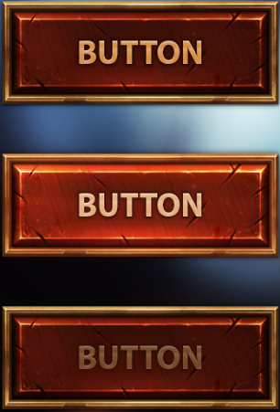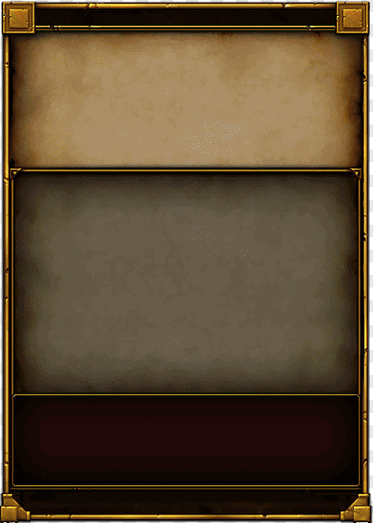
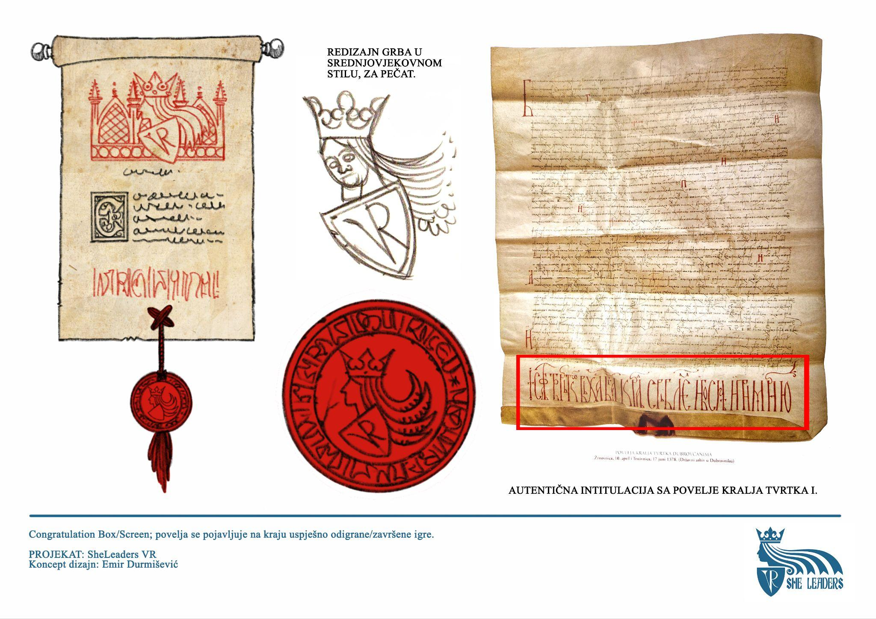
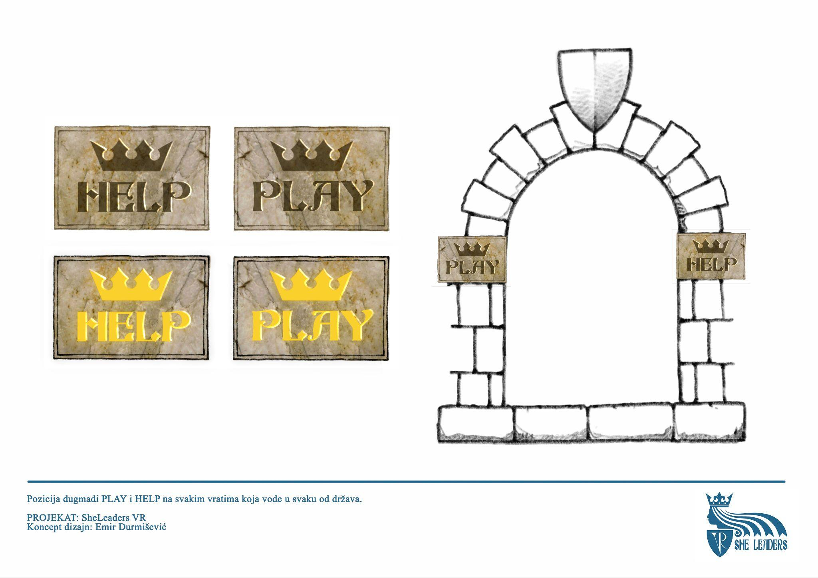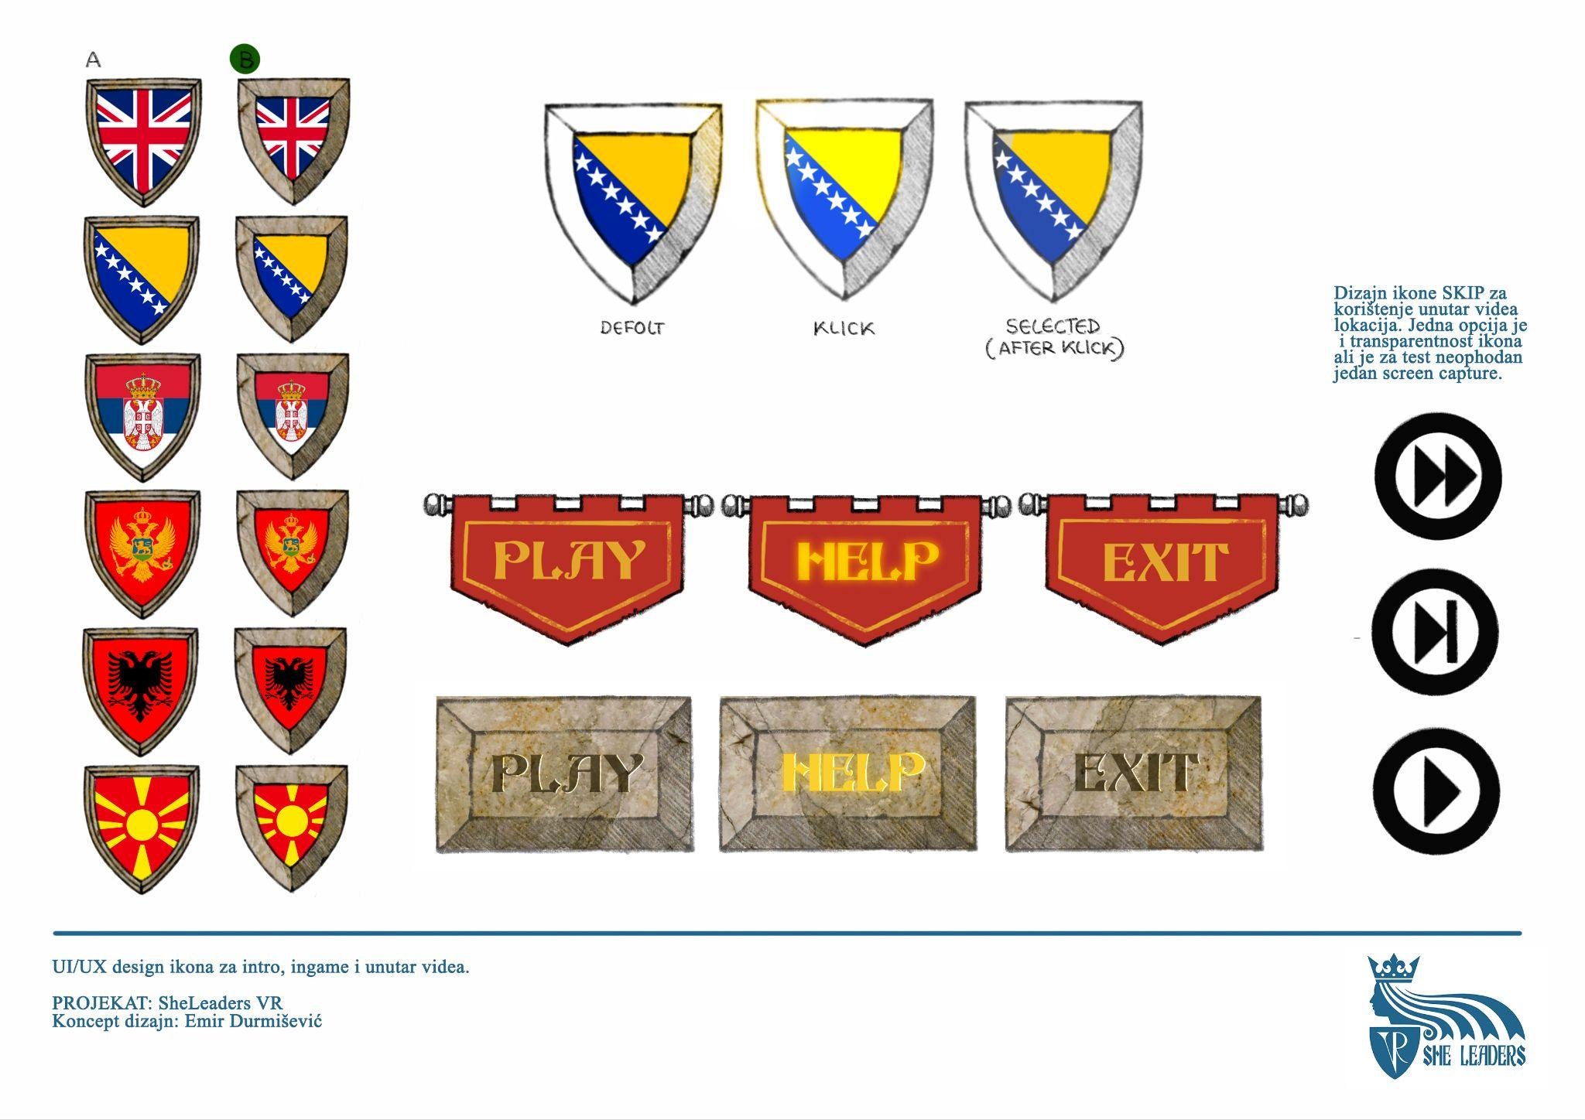
List of UI elements in the application:
Buttons on first screen
- Shields for the languages
Buttons in starting menu (same looks):
- PLAY
- HELP
- EXIT
Button in intro cinematic:
- SKIP
In-game button (starting room):
- HELP (inside wall structure)
- EXIT (inside wall structure)
Button in video cinematic:
- SKIP
Button for gameplay part:
- CONTINUE
Gameplay elements:
- Text-box - general text information (expandable)
- Small text-box - conversation answers
- Conversation box - NPC text for the user (scrollable)
- Text-box for artefacts - short texts for final room (scrollable)
- Parchment paper - Congratulations message for beaten game
- Additional menu box - inside with two buttons - RESTART & EXIT
- Portal-like passage 1 - Passage behind each door that leads to each country
- Portal-like passage 2 - Passage that has title above "RETURN TO THE PRESENT" and leads to the end credits
Additional things:
- Help screen - screen with two controllers that have explanation of each button

Person in charge: Emir D., Aida
Date for final delivery: 01.08.2023.

Intro cinematic

Intro animation starts playing after pressing the “PLAY” button. Length of intro cinematic should not exceed 1 minute. Cinematic should introduce the user with the context of the application and have a narrator explaining to the user that there was a disturbance in the timeline and that history is changing which can lead to the total destruction of the world we know. User is a time-traveller sent into the past to fix the timeline by finding various artefacts that need to be returned to their belonging places.

Idea: Cinematic could be done as a 360 motion graphics. It starts in front of the player as a drawing, which continues drawing itself to the right until it makes a full circle starting where it began. It will work in a VR environment but will also signal the coming of a full circle in solving the time paradox. Whole picture being drawn should in the end look like a thick ring around the user where the uppermost and lowermost part will be empty. In the bottom part of the “screen” there should always be a button “SKIP” which the user can press to skip the cinematic.

Cinematic scenario:
Elements: 5 countries, 5 female rulers, medieval time, tasks.
Cinematic
Draft teksta
Nekada davno na ovim prostorima postojase razna kraljevstva (spomenuti koje su godine) i razni vladari a medju njima i poznate Helena od Bosne, Milica iz Srbije, itd. Njihova ostavstina cini bitan dio nase vremenske linije. Ali mracna vremena su se nadvila nad nasom historijom i dogadjaji pokrenuti vremenskim upadima u nasu proslost bi mogla dovesti do totalnog unistenja svijeta kakvog znamo. Ti si nas izabrani heroj koji ce postati putnik kroz vrijeme. Uz pomoc posebnog uredjaja koji te ceka, moci ces putovati kroz prostor i vrijeme. Tvoj zadatak ce biti da pronadjes izgubljeni artefakt negdje duz nase vremenske linije i vratis ga vremenu kojem on pripada. Samo ako skupis svih 5 artefakta ces osigurati ocuvanje svijeta kakvog mi znamo. A sada kreni i osiguraj opstanak naseg vremena!
Person in charge: Aida
Narrator: NAME
Date for final delivery: 01.10.2023.

Poruka na kraju
Cestitamo! Uspjesno si obavio zadatak i vratio balans u vremensku liniju. Kao zahvalnicu ti dajemo titlu cuvara vremena, ali znaj... mracne sile uvijek vrebaju. Ako se potreba opet javi racunat cemo na tebe. A sada se odmori u sobi sa posebnom izlozbom prije nego se vratis u sadasnjost.

Starting room

This is the main room which serves as the starting position for a user. Room will have 6 doors of which 5 will lead to different stories about different female leaders in different countries. Room will have a pedestal in the middle with 5 empty spaces for 5 items which need to be recovered from each gameplay part of the experience. After all five items are placed on the pedestal the last door will be unlocked and the user can walk through. On the wall above these doors there should always be buttons “EXIT” and “HELP”. Pressing “HELP” will open a picture of the 2 controllers with each button explaining what it does in front of the user.
Idea: Room should look like a mediaeval castle room with doors placed around the player in hexagonal layout. Examples:
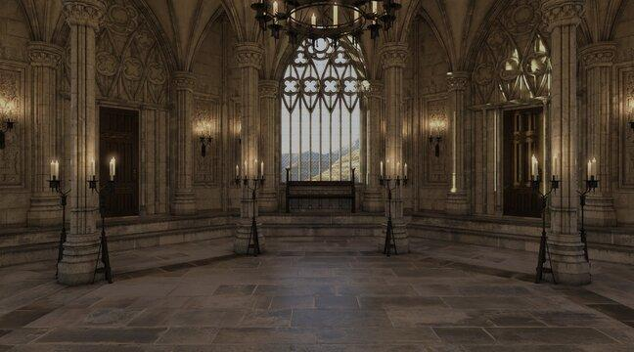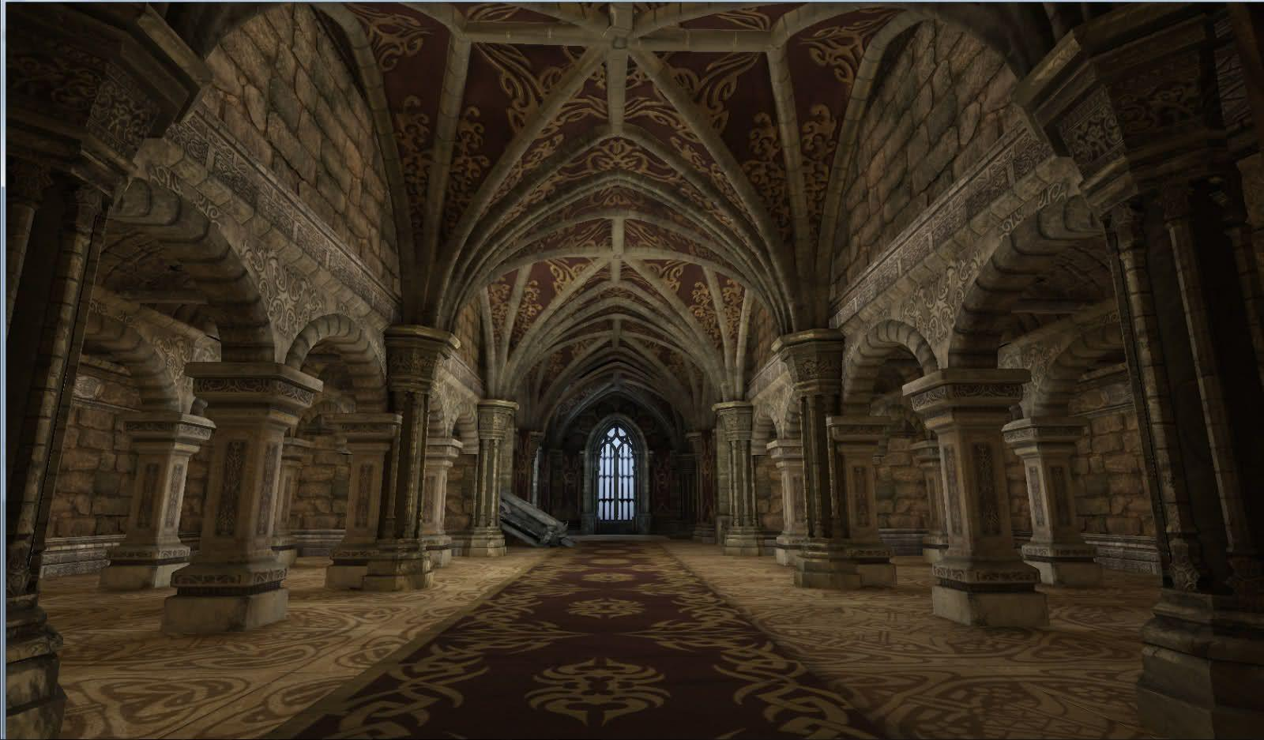
Person in charge: Emir D, Edin D.
Date for final delivery: 01.06.2023.
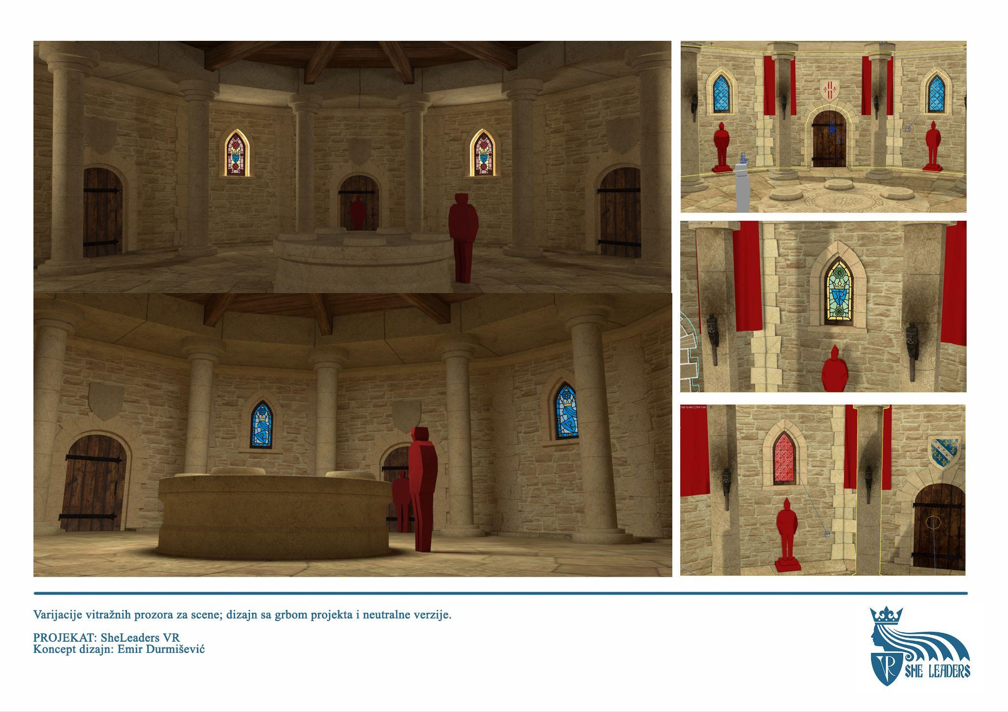

Final room

After placing all five items on to the pedestal, the sixth door should open. Behind it should be a small corridor which leads to the final room. As soon as the user steps into the corridor, the door behind closes and the message on the screen is displayed which congratulates the user on fixing the timeline and ensuring important memories of each female leader to be carried on from generation to generation. User is also invited to explore the final room before returning to the present. In the final room all 3D models made for this application should be placed on different display tables around the room which the user can interact with. Room will also have a portal like passage above which is written “RETURN TO THE PRESENT”. Passing through will display an ending splash screen which has all the credits and logos of the partners in the white space environment.
Idea: Final room should look like a mediaeval room filled with treasures. All the modelled objects should be scaled down and displayed here. When the user points toward the model, it will display its name and if the user clicks on it, it will display short text explaining what this model actually is. Messages which display on the screen could be written on paper parchment found in the UI design section.
Idea 2: Final room should look like a modern museum with small pedestals each holding one 3D model. All the modelled objects should be scaled down and displayed here. When the user points toward the model, it will display its name and if the user clicks on it, it will display short text explaining what this model actually is. Messages which display on the screen could be written on paper parchment found in the UI design section.
Examples:
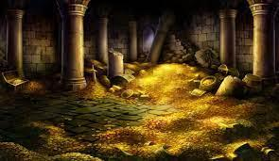

Person in charge: Edin D.
Text about items needs to be written by: NAME
Date for final delivery: 15.07.2023.
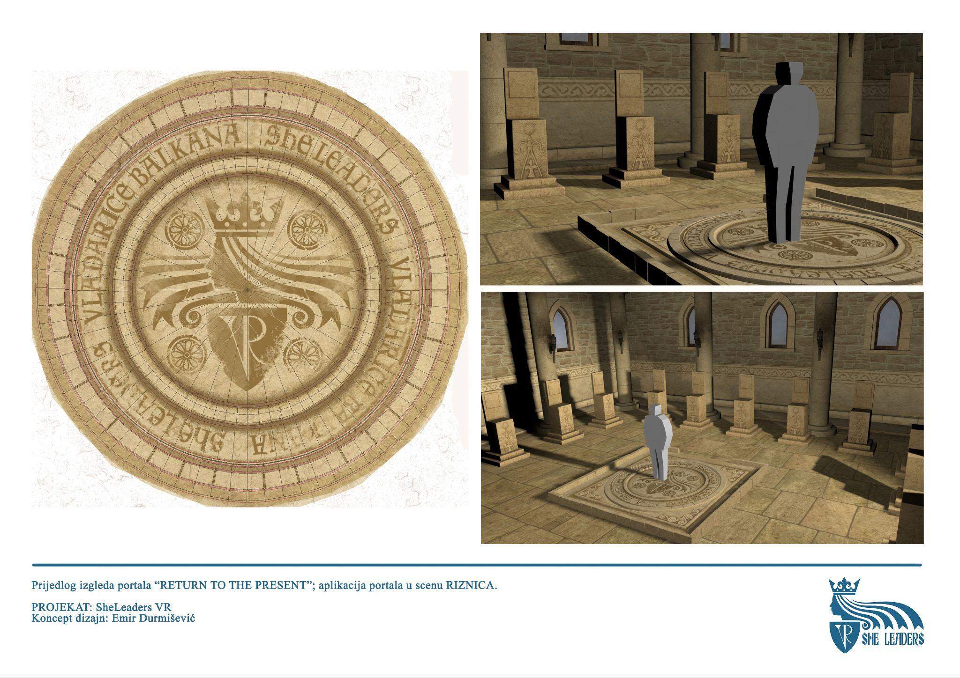

Custom controllers

3D models of both VR controllers in the application should be created and will have animations on them.
Idea: Controllers should look like mediaeval gauntlets with the left one having special attachment from the future which allows the user to teleport around the area and change his view from 3D environment to Quest cameras live feed and vice versa.
Example:
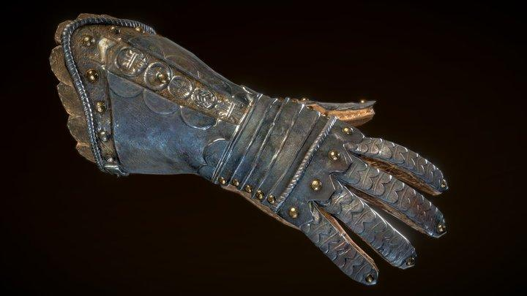
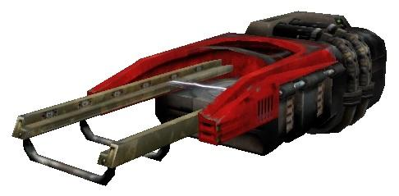
Person in charge: Festa M.
Date for final delivery: 15.10.2023.

Section design

Each door leads to a different country. Each section will be designed separately in a similar matter. Each section will start with a cinematic part which is made out of 360 videos playing in a sequence and actress added into the videos. On certain videos there will be different 3D models appearing or whole videos will transform into fully modelled environments. After cinematic which will not exceed 3 minute length, the user will be transported into a 3D environment. This is the start of the gameplay part. Textbox will appear in front of the user with text which specifies what artefact the user needs to find to finish the gameplay part. After finding the artefact, gameplay will pause and slowly fade to black. User will appear in the first room with an artefact which he acquired now in its place on the pedestal in the middle of the room.
The texts for different countries are as follows:
You have entered mediaeval Bosnia and Herzegovina. Queen's quarters stand before you. Your goal is to find "Trade Agreement" stolen by the time pirates. Use your "Transdimensioner" and look for the help in fire bearers... Hurry!

You have entered mediaeval Serbia. Tower stands before you. Your goal ist to find "Queen's earring" stolen by the time pirates. Use your "Transdimensioner" and seek for the answers behind the prison door... Hurry!

You have entered mediaeval Albania. Small chapel stands before you. Your goal ist to find "Bell" stolen by the time pirates. Use your "Transdimensioner" and seek for the answers outside the chapel... Hurry!

You have entered mediaeval Montenegro. Cetinje monastery stands before you. Your goal ist to find "Capitel" stolen by the time pirates. Use your "Transdimensioner”' and seek for the answers behind walls and bookcases... Hurry!

You have entered mediaeval North Macedonia. The Queen's palace stands before you. Your goal ist to find "Tombstone" stolen by the time pirates. Use your "Transdimensioner" and seek for the answers behind in the cluttered larder... Hurry!

For references of the locations you can use our field trip photos
https://photos.app.goo.gl/miUZ58teg1hz1G689

Bosnia and Herzegovina

Location: Bobovac castle
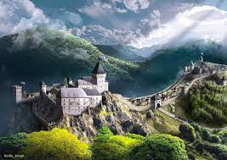
https://www.klix.ba/magazin/kultura/pogledajte-kako-je-izgledao-srednjovjekovni-bosanski-kraljevski-grad-bobovac/190201009

Set of videos: VIDEO 1, VIDEO 2, VIDEO 3, VIDEO 4
Videos which have 3D models added: VIDEO 3
Music background: musicGameplay*_loop_v1.wav (*=A, B or C randomly)
3D Models used: Documents about trade; Stone chair; MODEL NAME 01, MODEL NAME 02
Artefact model in gameplay: stone chair, documents about trade
https://sketchfab.com/3d-models/royal-and-judges-seat-of-queen-helen-of-bosnia-31827f31c8ed475c83443253341e3a66
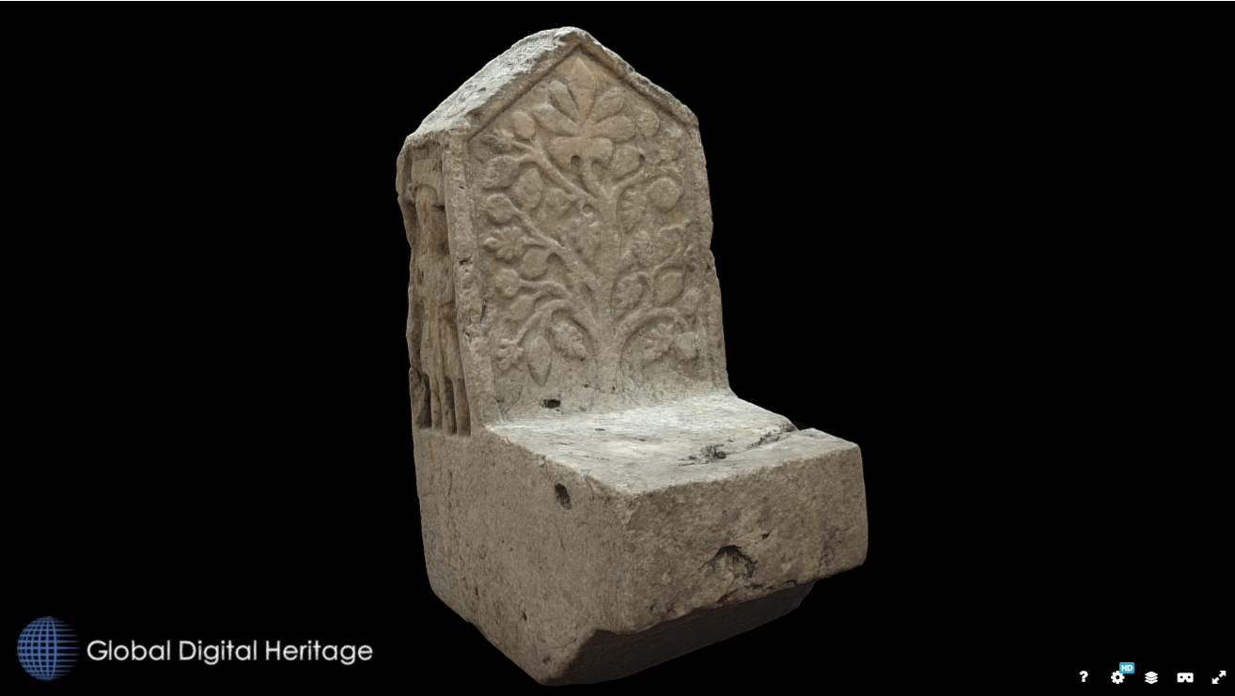

Gameplay environment: Hallway from the castle of Bobovac with one more room where the queen used to work.
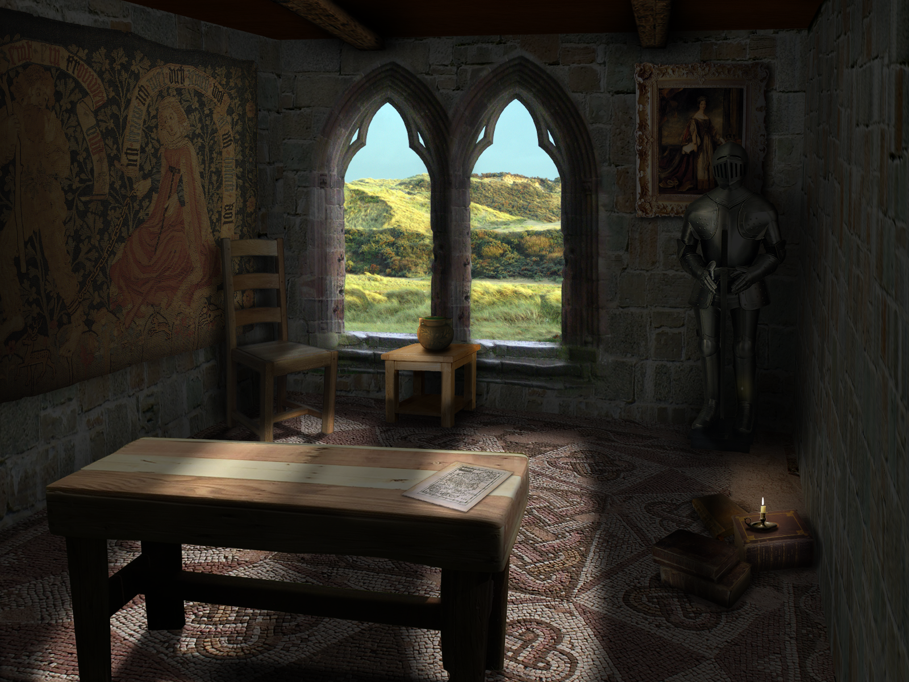
Person in charge: Festa
Date for final delivery: 15.07.2023.
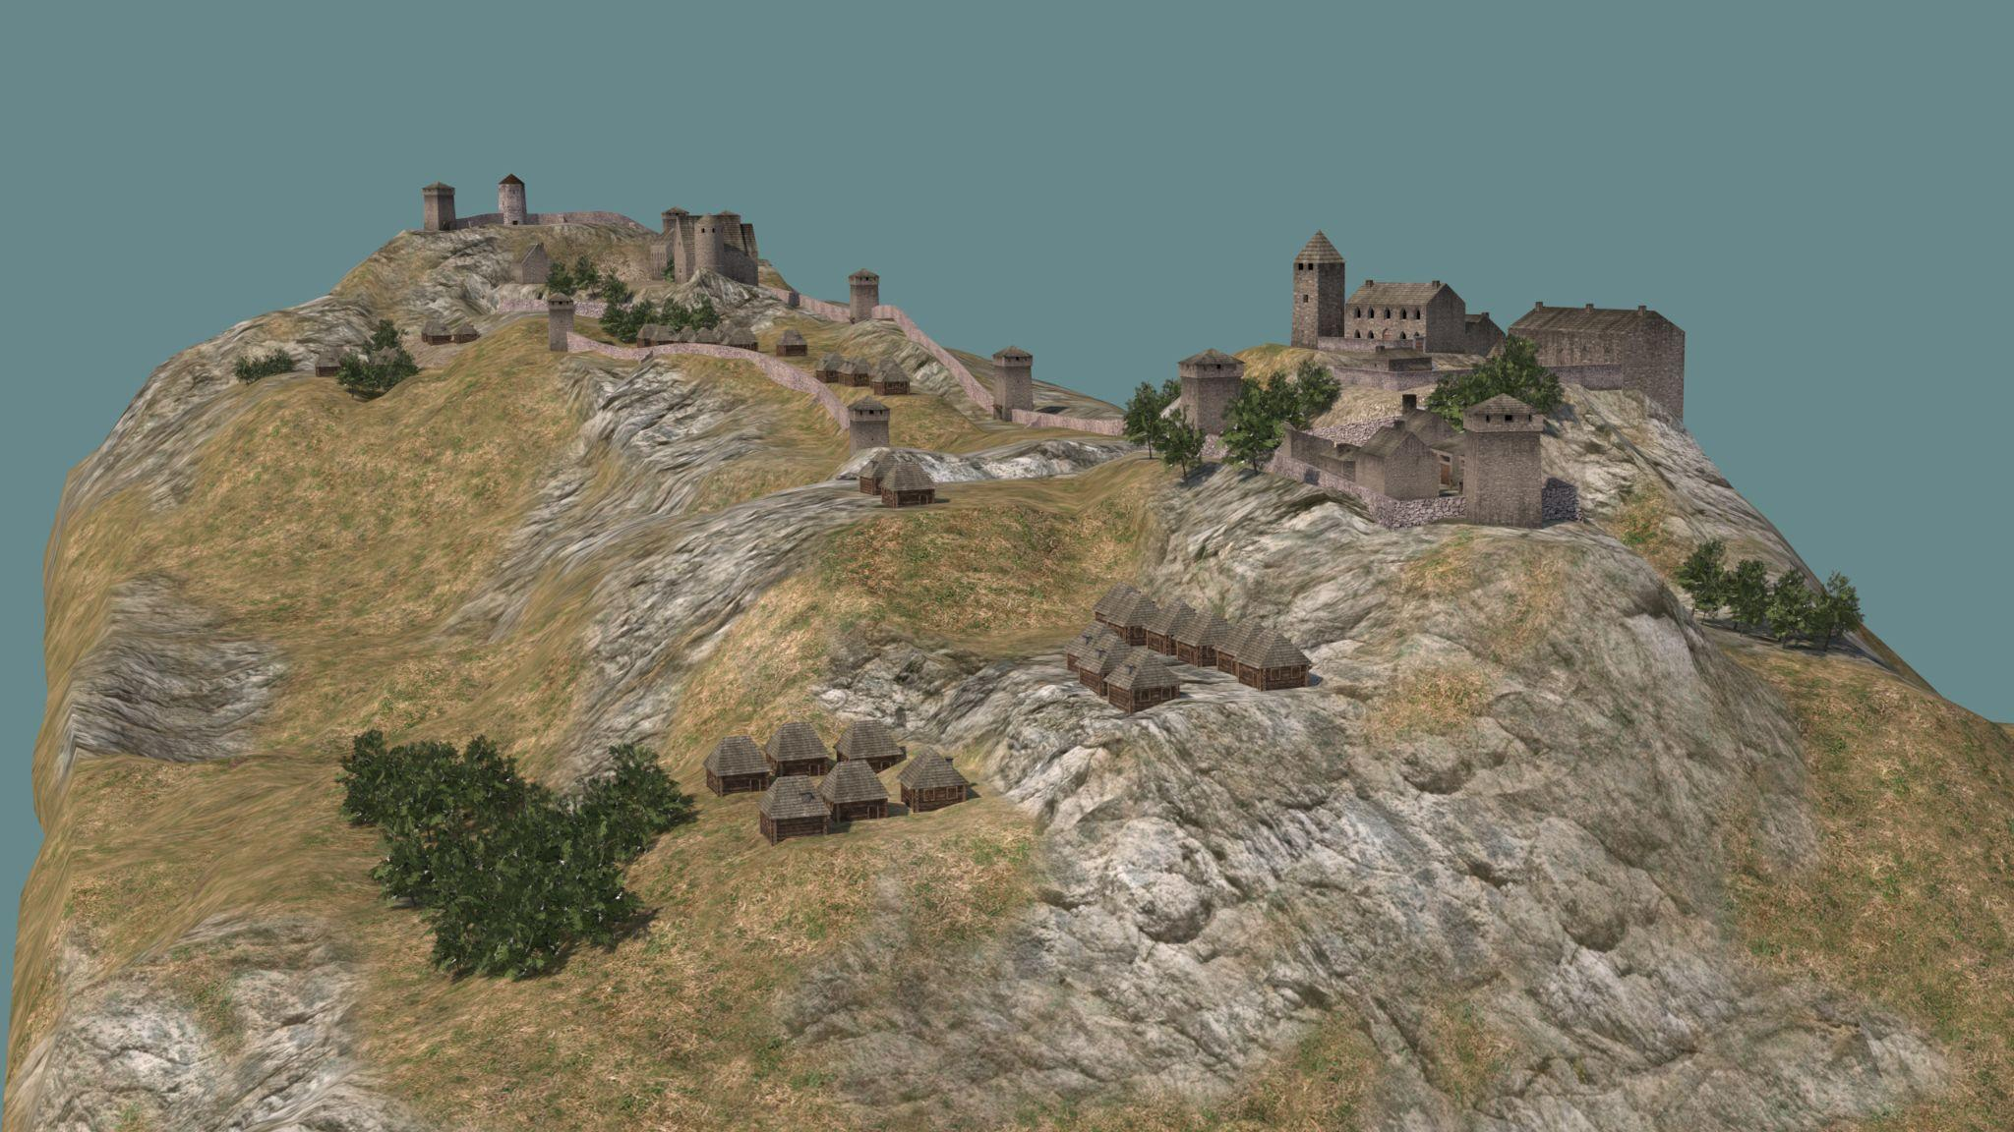
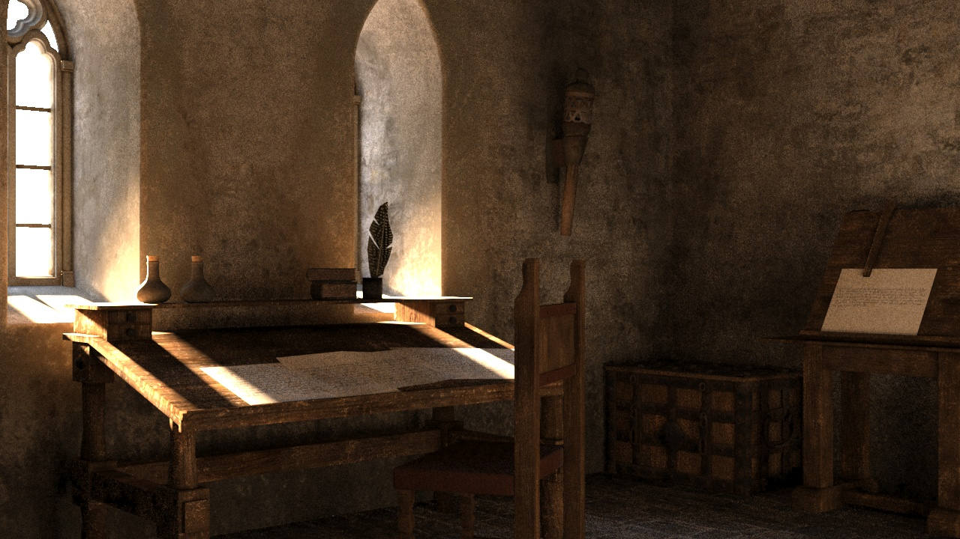
Gameplay design:
The user will start in the middle of the hallway. There will be few knights in the hallway and few peasants. There will also be a commander of the unit at the end of the hallway. Doors to the other room are locked. On the left side there is an empty room with a stone throne in the middle. User must speak to the commander and ask for the key. To have the option to ask for the key, the user must first try to open the door. Otherwise the user will only be able to ask the commander who he is. All the answers could be written in the small text bubbles above character heads. If a user tries the door, another question will appear: “Can you give me the key to the queen’s room?”. Commander will ask then: “When did Helen become a Queen”. Few choices in the form of text boxes will be offered to the user. “1395” is the right answer. If answered correctly the commander gives the key. Otherwise, the commander says “Wrong answer” and the user must try again. When the key is acquired, the user can open the door. In the room there is the table in the middle which will have documents about trade displayed on it and the chair. There are few torches on the wall, and there is an empty torch holder. User must find an unlit torch in the throne room and bring it here. It will be placed on the wall behind the throne. When the torch is attached to the wall, the other wall will open and reveal “BIH Artefact - Documents about trade”. When the user picks it up, the screen fades to black and gameplay is over.

Serbia
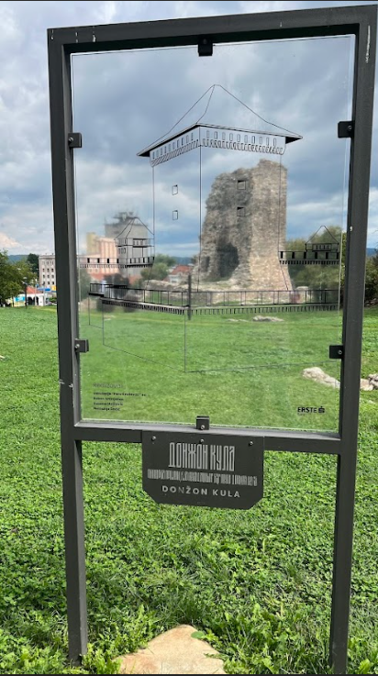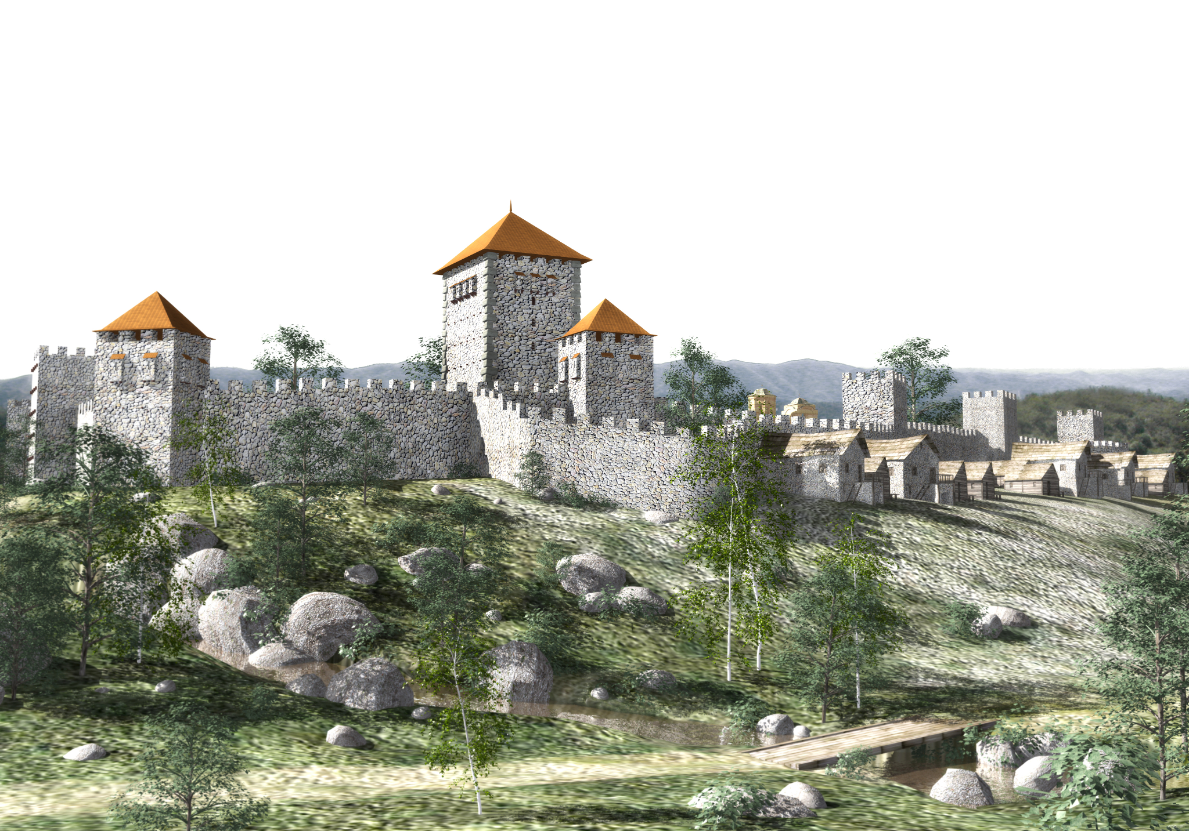
Location: Kruševac, Lazarica monastery, fortress Donzon, Ljubostinja monastery
Set of videos: VIDEO 1, VIDEO 2, VIDEO 3, VIDEO 4
Videos which have 3D models added: VIDEO 3
Music background: musicGameplay*_loop_v1.wav (*=A, B or C randomly)
3D Models used: Knife; Chalice; Earring; MODEL NAME 01, MODEL NAME 02
Artefact model in gameplay: MODEL NUMBER 22: EARING FROM SERBIA
Gameplay environment: Hallway from demolished Tower with stairs leading to the second floor.
Person in charge: Edin D.
Date for final delivery: 15.07.2023.
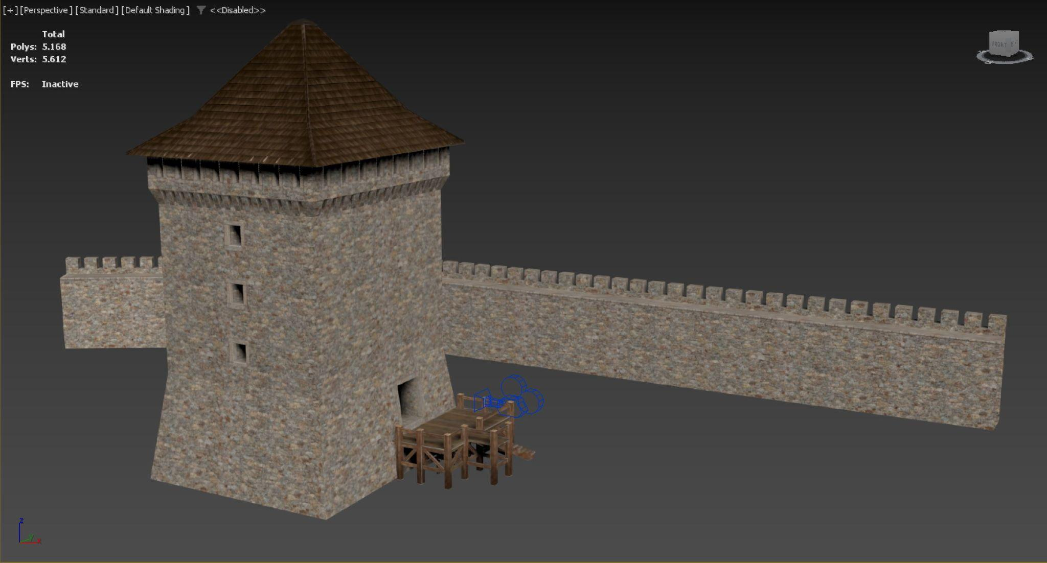
Gameplay design:
The user will start inside the tower with different knights around him and different things placed on the walls. One of the knights will be standing next to the lever in the wall. Behind the lever there will be a door which can’t be opened. If the user interacts with the knight, he will ask him: “What is the name of Princess Milica’s youngest daughter?” Few choices will be offered to the user and the correct one is “Olivera”. If the user answers correctly, the knight will ask him to unjam the lever. User must first take the knife (Serbian model) out of the knob and then grab it with their hand and pull down completely to open the door behind. Doors will be slowly sliding while the user is turning the knob. Behind the open door, there will be a staircase which the user can use to climb to the second floor. There will be a bookcase on one wall with many books. The user must remove dozens of books to reveal a small jewellery box behind which when interacted with will open up and reveal “Serbian Artefact: Earing” in it. When the user interacts with the earring, the screen will fade to black and gameplay is over.

North Macedonia

Location: Skopje Fortress (palace), Stone Bridge

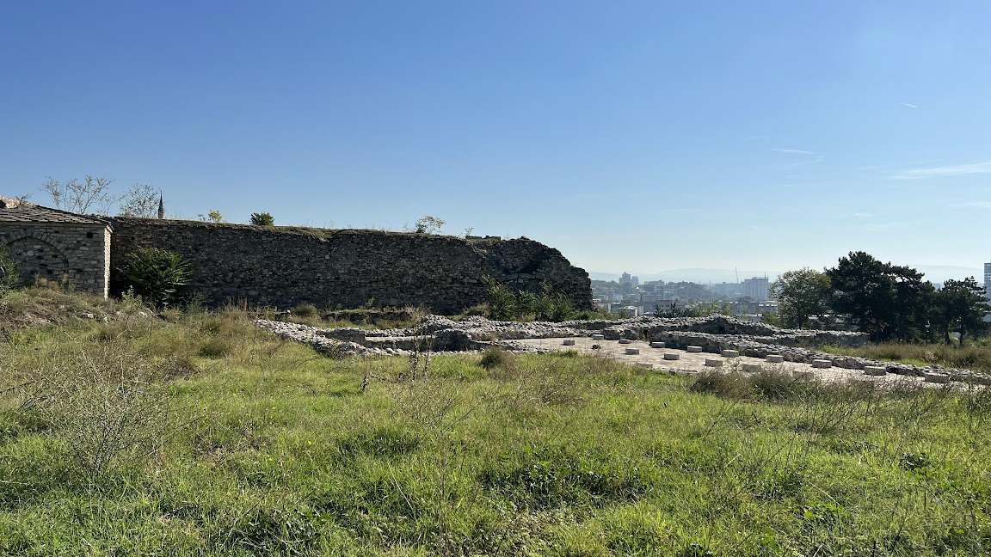
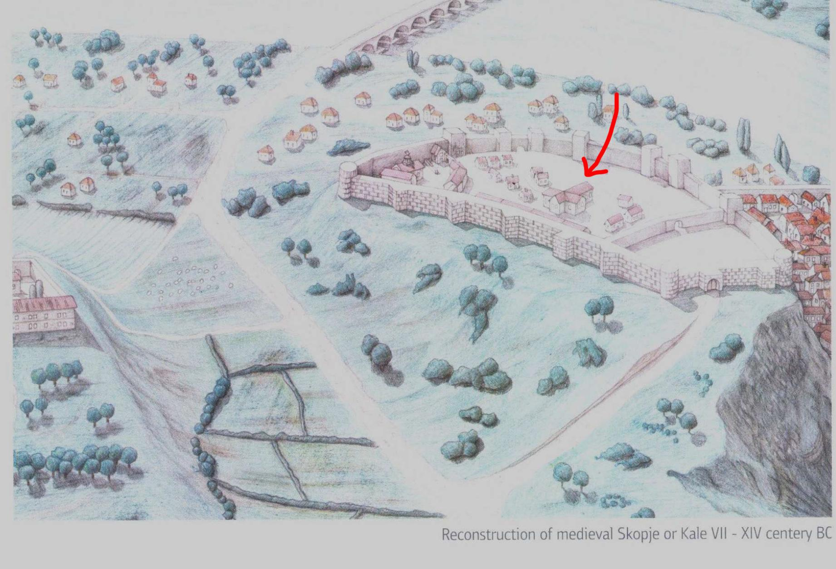
reference for the palace
: https://en.wikipedia.org/wiki/Palace_of_Blachernae
https://en.wikipedia.org/wiki/Palace_of_the_Porphyrogenitus
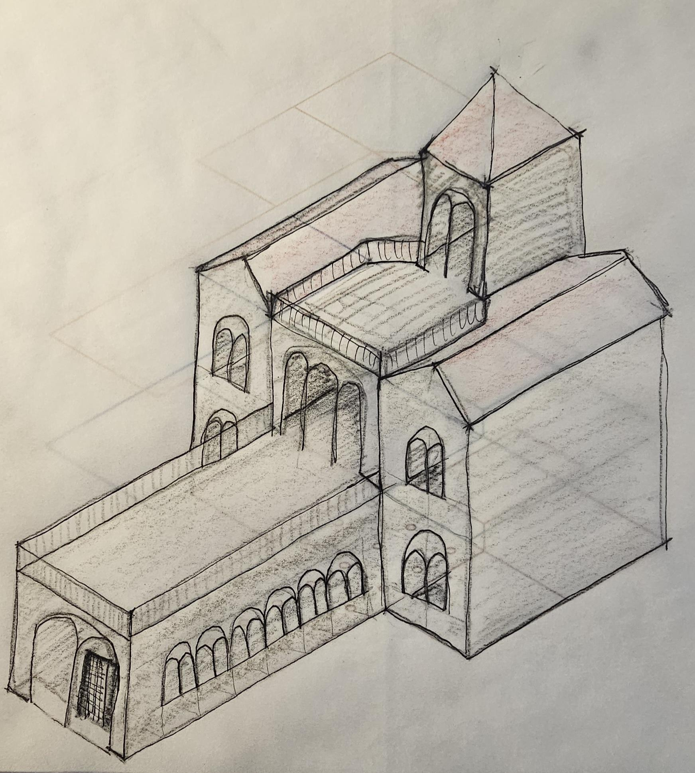
Set of videos: VIDEO 1, VIDEO 2, VIDEO 3, VIDEO 4
Videos which have 3D models added: VIDEO 3
Music background: musicGameplay*_loop_v1.wav (*=A, B or C randomly)
3DD Models used: Tombstone; Metal church ritual object; MODEL NAME 01, MODEL NAME 02
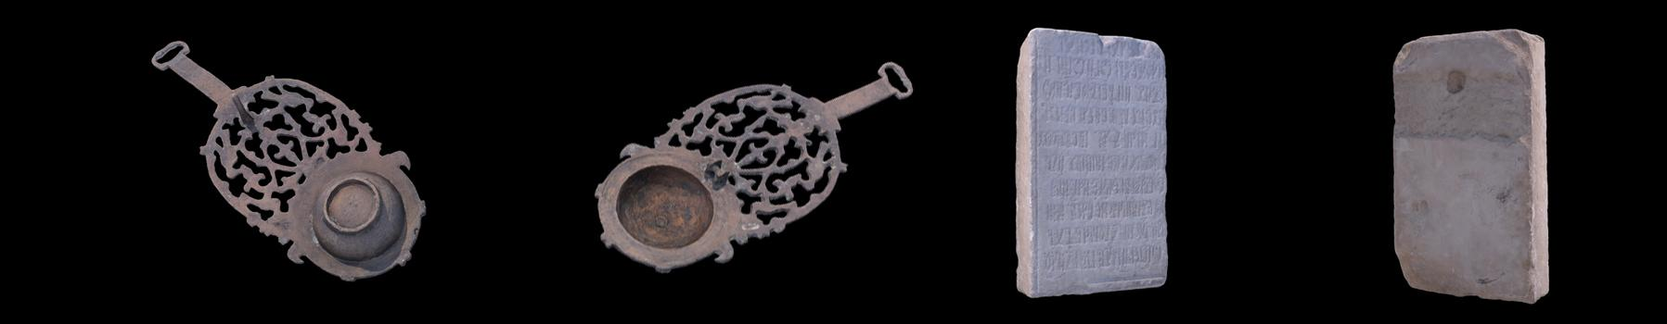
Artefact model in gameplay: ARTEFACT NAME 02
Gameplay environment: ENVIRONMENT 03
Person in charge: Aida
Date for final delivery: 15.07.2023.

Gameplay design:
The user will start the gameplay inside the palace. There will be few house maids, knights and the priest inside the big hall. The priest stands near the locked door of the larder. If the user interacts with the priest he will ask him to find his “ritual object”. If the user goes to the left room - a kitchen, a maid will ask the question: “"What was Queen Maria's husband's name?" Correct answer is Uroš. If the answer is correct the user will be able to enter the kitchen. Otherwise the user will have to try again. On the upper floor, another maid is standing in front of Queen's room and will ask for the broom so she could clean the room. The broom is located in the kitchen. If the user brings the broom, maid will enter the room and start cleaning. When that happens, the user can enter queen's room and retrieve "ritual object". After obtaining it, it can be given to the priest and then he will ask the user: "Where did the Queen presumably spend her last years of life?" Đurište Monastery is the correct answer. Afterwards. larder will be unlocked and inside the user will find many unused items. Behind huge crate which can be grabbed, user will find “Macedonian artefact: Tombstone”. When the user interacts with the tombstone, the screen will fade to black and gameplay is over.

Albania

Location: Kruja Basilica and castle
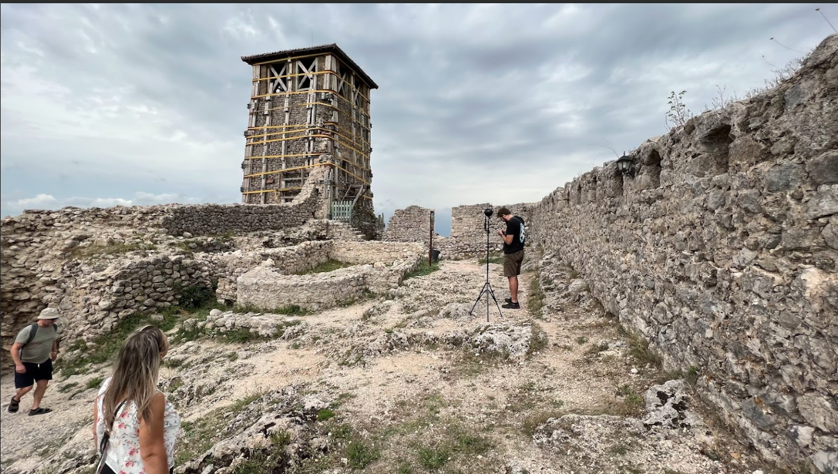
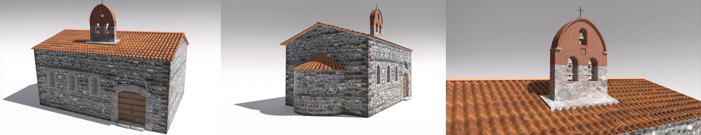

Set of videos: VIDEO 1, VIDEO 2, VIDEO 3, VIDEO 4
Videos which have 3D models added: VIDEO 3
Music background: musicGameplay*_loop_v1.wav (*=A, B or C randomly)
3D Models used: Bell; Coins; MODEL NAME 01, MODEL NAME 02
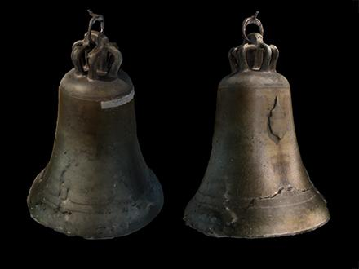
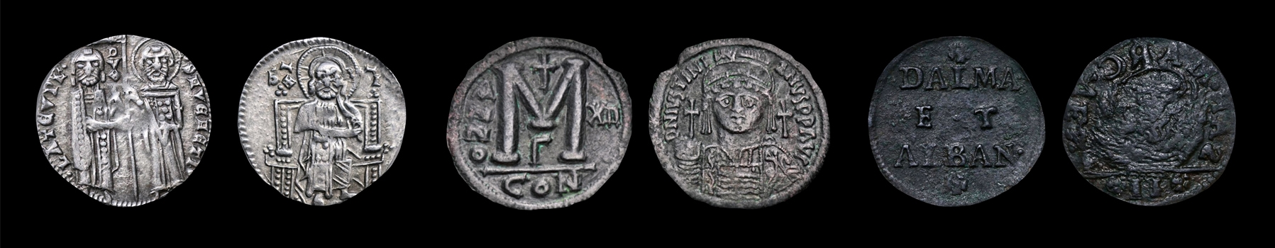
Artefact model in gameplay: MODEL NUMBER 14 – BELL FROM ALBANIA
Gameplay environment: Basilica interior.
Person in charge: Aida
Date for final delivery: 15.07.2023.
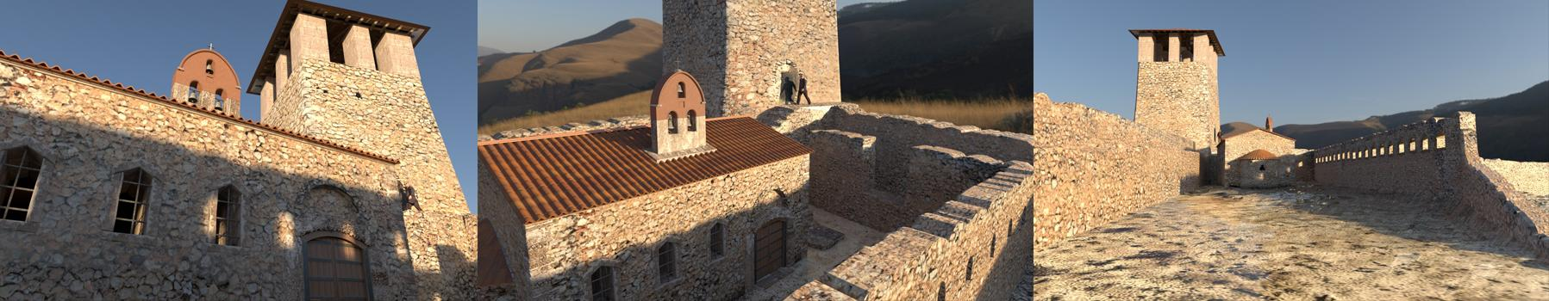
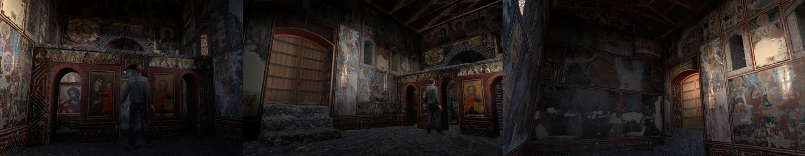
Gameplay design:
User starts the gameplay inside the small church. There is a priest inside the church. The user can interact with the priest and he will ask them which Pope proclaimed Iskander Champion of Christ? “Calixtus III” is the correct answer to the priest. After that he will request some coins for the poor box. The user should collect coins that are on the floor and put them inside the box. Priest will then give the user a “Key” to open the door and go outside. Area around the church will now be filled with peasants. There is a ladder laying down not far from the church. The user can pick them up and place them alongside the church to climb up and take the “Albanian artefact: Bell” which is sitting on the roof. Screen will fade to black and gameplay is over.

Montenegro

Location: Old Monastery, Church remains with pillars, Printing room, Stone panel with encryptions
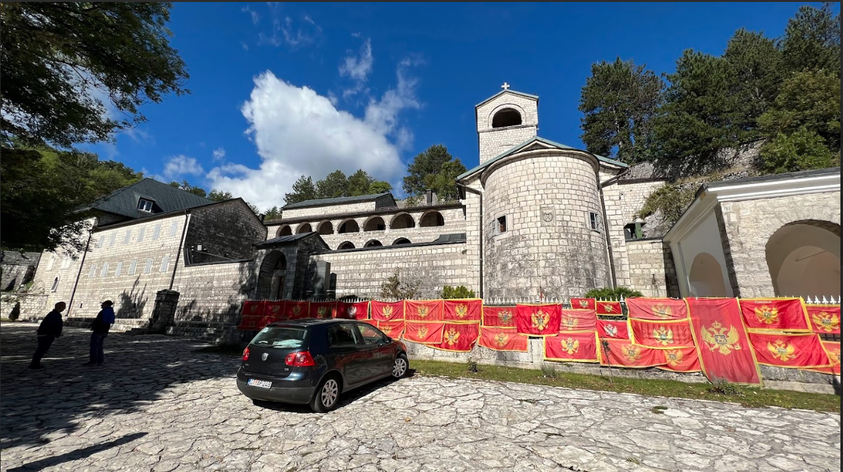

Set of videos: VIDEO 1, VIDEO 2, VIDEO 3, VIDEO 4
Videos which have 3D models added: VIDEO 3
Music background: musicGameplay*_loop_v1.wav (*=A, B or C randomly)
3D Models used: Capitel; Printing press; MODEL NAME 01, MODEL NAME 02
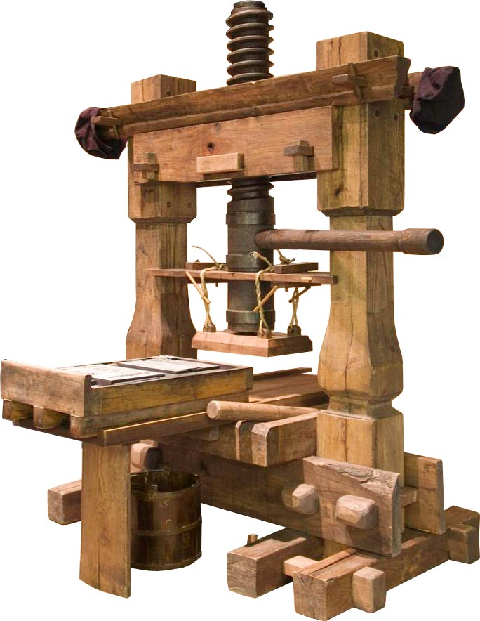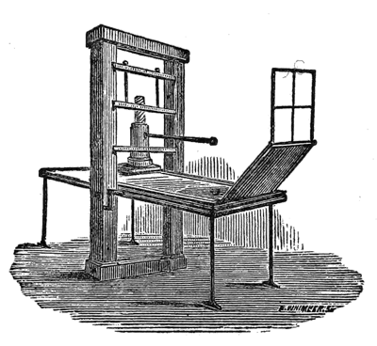
Artefact model in gameplay: MODEL NUMBER 17: CAPITEL FROM MONTENEGRO
Gameplay environment: Interior of the old monastery with two rooms. Inside one room is a printing press and another one is used for baptism.
Person in charge: Festa
Date for final delivery: 15.07.2023.
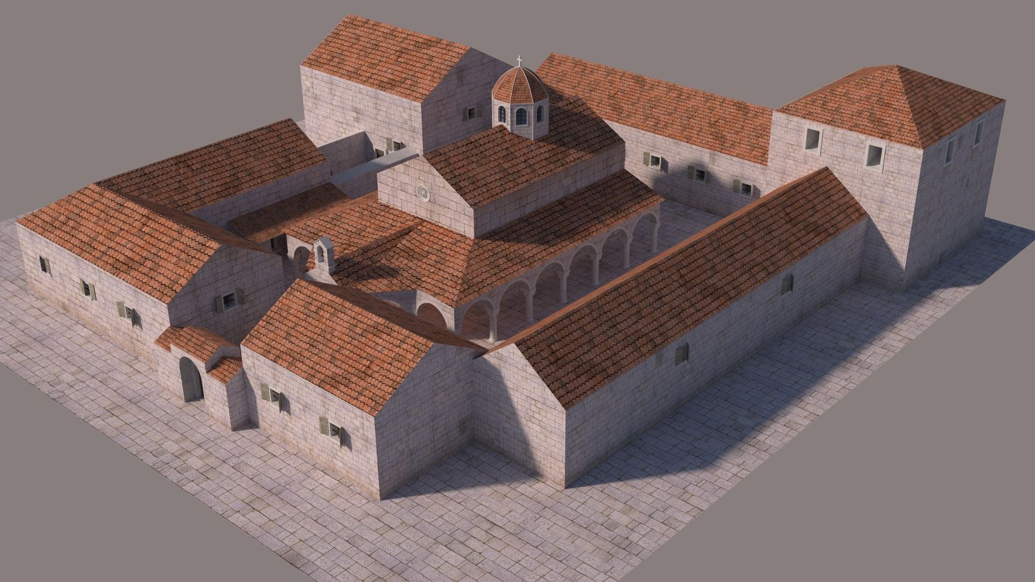
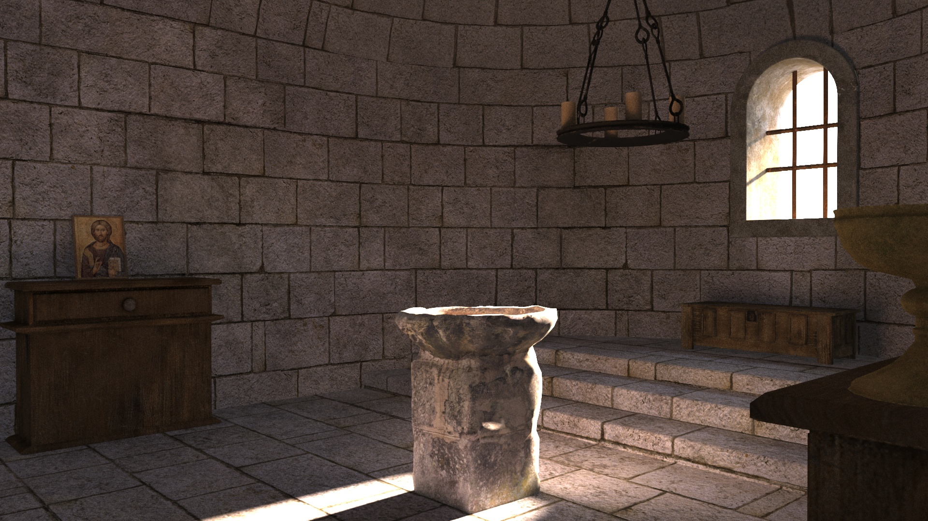
Gameplay design:
User starts the gameplay in the middle of the Old Monastery interior hall. There are many people around him. On each side of the hall, there is a small room. Somewhere in the hall, the user can find the Stone panel with encryptions, which will be sticking out of the wall a bit. It should also be pulsating with dim light around it. Using the grab function, the user can take the stone panel out. Behind the wall, in a small hole, there will be a key. One of the small rooms is used for baptism and on the floor behind the altar is a small locked chest. If the user has found the key in the wall, it can be opened. Otherwise, it is locked and the message will be displayed “It’s locked”. When the chest is open, inside is a hook which can be collected with a grab button and carried around. Room on the other side of the hall is the one with the printing press. Doors are open, but in front of the door is a guard blocking the passageway. If the user interacts with the guard, he will ask: “Where is the Monastery of Our Lady located?” The correct answer is “Cetinje”. If answered correctly, the guard will move away from the door and the user can now pass into the room. In the middle of the room is the printing press machine. If the user has recovered the hook from the chest, with the hook he can grab the chain hanging from the ceiling above the printing press. This will open the wall behind the printing press and reveal the hidden place with “North Macedonian artefact: Capitel” inside it. The user can now interact with it, and the screen will fade to black and gameplay is over.

Actress filming on Chroma key

Ten videos in total should be recorded. First 5 stories written in the first 5 scenarios will be used for VR applications. Second 5 stories will be used for AR application. Scenarios for AR application need to be translated and exact museums selected.
Person in charge: Bojan Mijatovic
Date for final delivery: 30.05.2023.

Bosnia and Herzegovina VR scenario

Costume: COSTUME NAME AND EXAMPLE
Makeup: MAKEUP EXAMPLE
Scenario:
Helen of Bosnia
We often had sleepless nights, even under the safe hand of King Dabiša. ...My husband.
Messengers came and went, bringing news of Hungarian aspirations... They knew Tvrtko’s powerful kingdom had been weakened. Brewing around Bosnia was a dark foreboding... The abyss opened up on the 5th of September 1395, when King Dabiša forever closed his eyes.
The agreement struck between King Sigismund of Hungary and King Dabiša could not be enforced, and so the Bosnian Stanak entrusted me, Queen Helen, to rule the kingdom.
I know my reign depended on cooperation with Bosnian nobles – the Grand Duke of Bosnia Hrvoje Vukčić, Prince Pavao Radinović, Duke Sandalj Hranić and Lord Batal Šantić. And I was there, perhaps gone tomorrow, always on guard, always careful not to tread on any of their toes. I felt then that a crown and a head on my shoulders were one and the same.
My Bosnian crown’s stability was aided by the dismal defeat of King Sigismund at the hands of Ottoman troops in 1396, giving him plenty of his own troubles to occupy his time. I managed to provide the merchants of Dubrovnik, subjects of the King of Hungary, unimpeded growth of trade when in mid-May 1397, I abolished the customs duties they had complained about. But, with time, as Hungarian pressure slackened, internal conditions grew for a dethroning.
By 1398, I, Queen Helen of Bosnia, was no more.
We learn this from the Dubrovnik Senate that now addresses emissaries of King Stjepan Ostoja... Dragiša was in Dubrovnik on the 20th of May as an emissary of the Bosnian king, and on the 11th of June 1398, the first official and honorary delegation was sent from Dubrovnik to the newly crowned King of Bosnia.
Though I lost my royal crown, it seems I kept in touch with the court.
News of me gets lost in the fog of future events.

Bosnia and Herzegovina AR scenario

Ja sam Jelena Gruba, bosanska kraljica. Nalaziš se u najznačajnijem srednjovjekovnom gradu u Bosni i Hercegovini - Bobovcu. Znanje o meni nagrizaju oluje nad zvonicima vremena. Svijet kakav pamtimo mogao bi nestati. Tebi se obraćam! Ja sam ovamo, a ti... tamo. Ja sam znanje, a ti čuvar znanja. Tvoja je dužnost da odeš u "Zemaljski muzej u Sarajevu". Tu ćeš naći upute i ključ od vremenske crte. A sad požuri, jer vrijeme... vrijeme nestaje.

Serbia VR scenario

Costume: COSTUME NAME AND EXAMPLE
Makeup: MAKEUP EXAMPLE
Scenario:
Princess Milica of Serbia

Though I am of high and noble birth, from the holy tribe of Simeun Nemanja, the first Serbian Lord, my greatest crown is that I am the widow of the honourable Prince Lazar of Serbia, killed in the Battle of Kosovo. To him I sing my sorrow and to the Blessed Virgin I pray, for a great force of menace is looming over Serbia...
Dark clouds rise from all directions... Not just the heathens from the East, but the Hungarian Kingdom too, waiting to pillage our land. Much blood was spilled. I hear sorrow and inconsolable weeping. I look at my children, five daughters, and my sons Stefan and Vuk, scarcely past their boyhood. I pray to God to show them the way.
Not three months since the Battle of Kosovo... I have a choice before me: Relinquish the land to King Sigismund of Hungary, or preserve the land, but give my youngest daughter Olivera’s hand in marriage to Sultan Bayezid.
In a sea of sacrifice, which is lesser? Which bodes survival, which vanishes? And which return? Will I manage to transfer the remains of Great Martyr Lazar from the Church of the Holy Resurrection in Pristina to the Ravanica Monastery, the Prince’s own endowment? If with the help of the Sultan I restore the lands taken by the Hungarian King? If I halt the Sultan’s retributions? If I rule with a manly hand until my Stefan is old enough to succeed his father. ...And that is in four more years.
Then I shall take my monastic vows, retreat to the Ljubostinja Monastery by Trstenik and become the nun Eugenia. I shall build and gift churches and monasteries, prostrate myself before God, and call only on Him and the Holy Mother for help. I know the Lord, having seen such trials and tribulations, shall not leave His good people of Christ to their enemies’ disdain, but shall provide comfort and relief.
By God’s grace, I shall reconcile my sons Stefan and Vuk at the Sultan’s court. I shall preserve my children, my people and Serbia. May my life be a signpost to the Kingdom of Heaven where I shall join Lazar.

Serbia AR scenario

Ja sam Kneginja Milica, žena kneza Lazara i vladarka Srbije nakon Kosovske bitke. Nalaziš se u Lazarici. Znanje o meni nagrizaju oluje nad zvonicima vremena. Svijet kakav pamtimo mogao bi nestati. Tebi se obraćam! Ja sam ovamo, a ti... tamo. Ja sam znanje, a ti čuvar znanja. Tvoja je dužnost da odeš u muzej grada Kruševca. Tu ćeš naći upute i ključ od vremenske crte. A sad požuri, jer vrijeme... vrijeme nestaje.

North Macedonia VR scenario

Costume: COSTUME NAME AND EXAMPLE
Makeup: MAKEUP EXAMPLE
Scenario:
Maria Palaiologina
I am the nun Marta. At the end of my earthly road. Devoted to God and His service.
The death of my husband Stefan Uroš III Dečanski set the grindstone of history in motion. In that name, the monastery became my new home. I took my vows to await eternal rest while serving God.
I was Maria Palaiologina. Queen, married to Uroš III in 1324. He was a widower, I his second wife. Six years I served the Kingdom and the King, until his death in 1332.
I was born in Constantinople. I later lived in Thessalonica where my father John Palaiologos became governor in early 1320. I was the great-niece of Emperor Andronikos II Palaiologos, the granddaughter of (megas logothetēs) Theodore Metochites, and my hand in marriage was worthy of Uroš III.
Thus, the Skopje Fortress became my home. The seat of Serbian kings in the 13th and 14th centuries. The strong Stone Bridge where King Stefan Dušan was crowned. There is also the Church of St Demetrius, where one day someone will install a tombstone with my name on it or perhaps an account of my life.
It was during the reign of Dušan the Mighty, on the 7th of April 1355 that I bequeathed my soul to the Almighty.
My grave, somewhere in the vicinity of Skopje, has been trampled by time.
Only a single earring, with an eagle and my monogram, was found in a grave and bears witness that I may have spent the last years of my years in the Đurište Monastery.

North Macedonia AR scenario

Ja sam Marija Paleologos, kraljica. Služila sam Kraljevstvo, i Kralja Uroša, do njegove smrti 1332.godine. Nalaziš se u mojoj palati u Skopju. Znanje o meni nagrizaju oluje nad zvonicima vremena. Svijet kakav pamtimo mogao bi nestati. Tebi se obraćam! Ja sam ovamo, a ti... tamo. Ja sam znanje, a ti čuvar znanja. Tvoja je dužnost da odeš u muzej Makedonije. Tu ćeš naći upute i ključ od vremenske crte. A sad požuri, jer vrijeme... vrijeme nestaje.

Albania VR scenario

Costume: COSTUME NAME AND EXAMPLE
Makeup: MAKEUP EXAMPLE
Scenario:
Voisava Kastrioti

I bore him four sons and five daughters:
Reposh, Stanisha, Konstandin and Gjergj... Mara, Jelena, Angelina, Vlajka and Mamica.
My husband, the ruler of Albania, Prince of Epirus, Gjon Kastrioti, turned to silence when the Ottomans abducted our sons. ...My sorrow too was unspoken.
It was blackmail. We became the Ottomans’ prisoners in the name of parental love.
They told us: Your sons will receive a good education and high offices. ...But that cannot replace their stolen liberty.
Though our Gjergj was educated at the Sultan’s court and became such a valiant warrior that the Ottomans referred to him as Iskander after the legendary Alexander of Macedon, he never forgot the past.
Our Gjergj sent word that he would return to rescue us from this evil. Thus originated the legend of the birth of Gjergj Kastrioti Skenderbeg, my son, fighter of Ottoman occupiers, proclaimed Champion of Christ by Pope Calixtus III.
Marinus Barletius, my son’s biographer, wrote down and expanded my account of a dream I had the night I conceived my son. With Gjergj in my womb, a vision of freedom was born:
...A powerful, huge serpent is coming, so big as to cover all of Epirus, extending its head to the boundaries of the Ottoman Empire with the intention of swallowing it up in revenge. The serpent’s tail reaches the seashore between the Christians and the Venetian Empire.
My dream was modelled after that of Olympias, the mother of Alexander the Great. Besides, my Gjergj was renamed Iskander by his Ottoman abductors.
I am Voisava Kastrioti. I lived in the shadow of pain and pride. Kept secrets and legends. The secret of my lineage remains.
Am I of the Branković dynasty? Am I the daughter of Grgur of Polog? Did I issue from the Musachi family?
Marinus Barletius, Skenderbeg’s biographer, says I am the daughter of a “tribal nobleman” from the Polog region. Through my time, all the rivers of the southern Balkans run.
I stand before history as the mother of Gjergj Kastrioti Skenderbeg, Albania’s national hero.
My womb gave birth to a dream of freedom.

Albania AR scenario

Ja sam Vojsava Tribalda, majka Đurađa Kastriota Skenderbega, nacionalnog heroja Albanije. Nalaziš se u Kruji, na mjestu gdje je nekada bila bazilika. Znanje o meni nagrizaju oluje nad zvonicima vremena. Svijet kakav pamtimo mogao bi nestati. Tebi se obraćam! Ja sam ovamo, a ti... tamo. Ja sam znanje, a ti čuvar znanja. Tvoja je dužnost da odeš u muzej u Tirani. Tu ćeš naći upute i ključ od vremenske crte. A sad požuri, jer vrijeme... vrijeme nestaje.

Montenegro VR scenario

Costume: COSTUME NAME AND EXAMPLE
Makeup: MAKEUP EXAMPLE
Scenario:

Izabeta Crnojević
Years of separation from my husband Đurađ Crnojević, the deposed ruler of Montenegro... Years of waiting and hoping...
In 1501, Đurađ was going to mount a rebellion in Montenegro, but he was arrested and taken to Istanbul. I have long been in Venice, my birthplace, surrounded by memories...
(After speaking the previous sentences “to herself”, she goes on to address us.)
I am Izabeta Crnojević, daughter of Paolo Enrico, the Venetian governor of Kotor, and the second wife of Đurađ Crnojević who ruled Montenegro.
Đurađ and I, we tried to bring the colours of the Renaissance to Montenegro, in both paintings and verses.
In Venice, we purchased a printing press, the first, they say, among the Southern Slavs and the second Cyrillic printing press in all the lands inhabited by the Slavs. The printing press was operated out of the Monastery of Our Lady in Cetinje and was a point of pride for Đurađ Crnojević.
Who would have thought that its letters would leave a trace in time, about Đurađ and his wife Izabeta.
In June 1490, my Đurađ succeeded his father Ivan Crnojević. Those were difficult times, squeezed between the Ottoman Empire and the Venetian Republic. It was in 1496 that Đurađ agreed to the plan of the French king Charles VIII to mount a rebellion in neighbouring Albania. When they learned of this, the Ottomans ordered him to leave Montenegro. We retreated to our estate near Budva, and later to the Venetian Republic.
Đurađ could not live down having his land taken away. His rebellion suffered an honourable defeat.
Word reached me that sometime around 1511, my husband Đurađ, the deposed ruler of Montenegro, had died in Anatolia.

Montenegro AR scenario

Ja sam Izabeta Crnojević, druga žena svrgnutog crnogorskog vladara Đurađa Crnojevića. Nalaziš se na Cetinju, na mjestu gdje je nekada bio manastir. Znanje o meni nagrizaju oluje nad zvonicima vremena. Svijet kakav pamtimo mogao bi nestati. Tebi se obraćam! Ja sam ovamo, a ti... tamo. Ja sam znanje, a ti čuvar znanja. Tvoja je dužnost da odeš u Narodni muzej Crne Gore. Tu ćeš naći upute i ključ od vremenske crte. A sad požuri, jer vrijeme... vrijeme nestaje.

360° Videos field recording

Each location must be visited and videos of the location recorded with two different 360 cameras. End products should be 8K stereoscopic 360 videos and 5.7K monoscopic videos. These will be used in the application storytelling section for creation of cinematics.
Person in charge: Bojan Mijatović
Date for final delivery: Done

Makeup section

Makeup and masking of each character is done according to the suggestions made by experts from each location. Any examples of masks and makeup can be added to this section. Any additional information needed for the makeup can be added to this section.
Examples:
Person in charge: Naida Đekić
Date for final delivery: 30.05.2023. - Done

Costume section

Costumes for each character are designed according to the suggestions made by experts from each location. Any examples of costumes can be added to this section. Any additional information needed for creation of the costumes can be added to this section.
Examples:
BH - Jelena
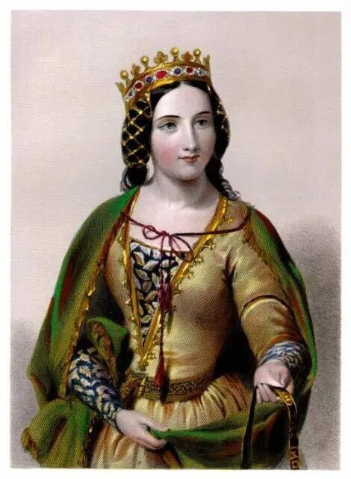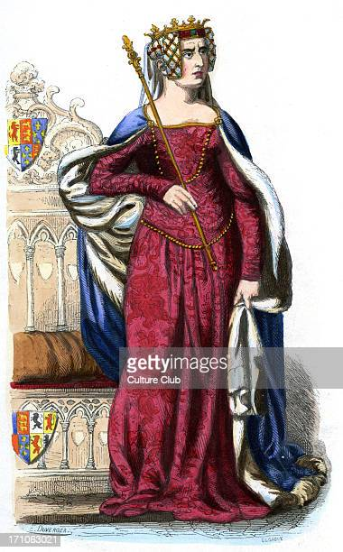
SR- Milica
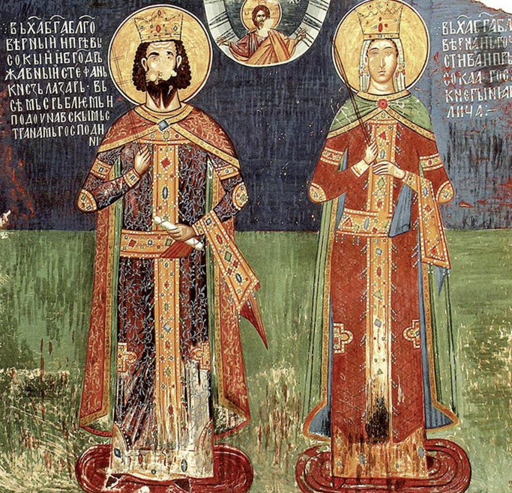
MNE - Izabeta
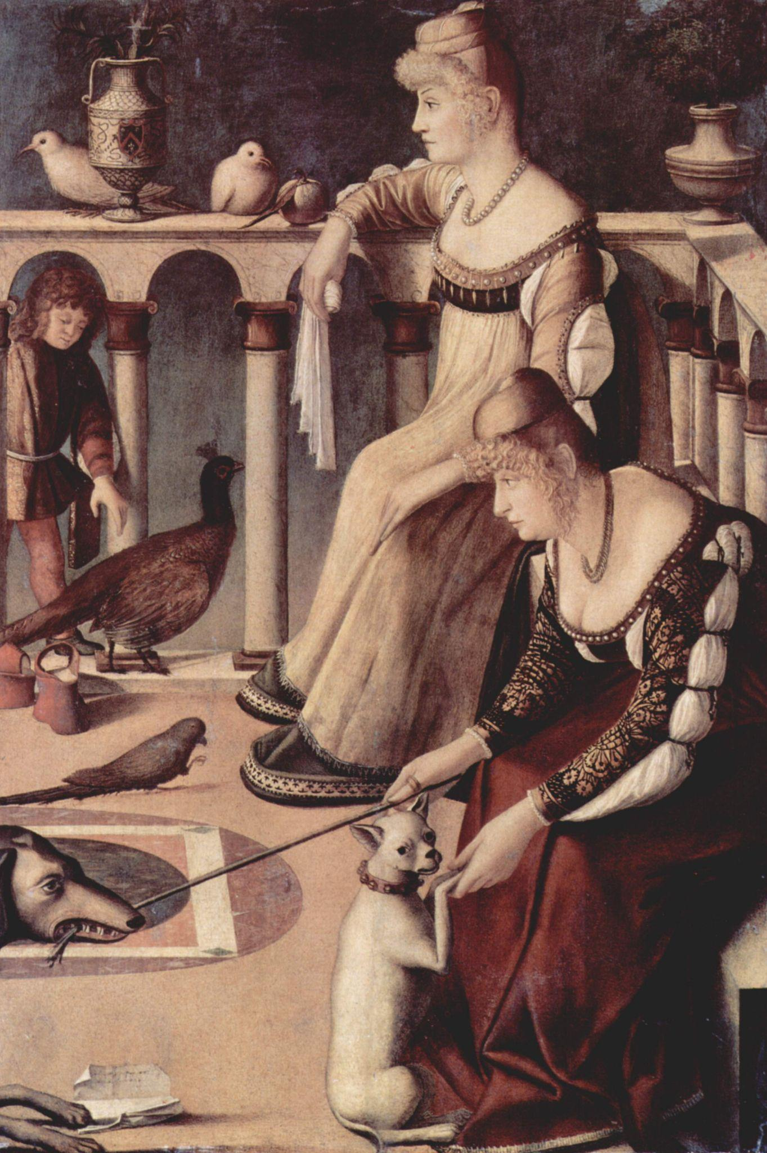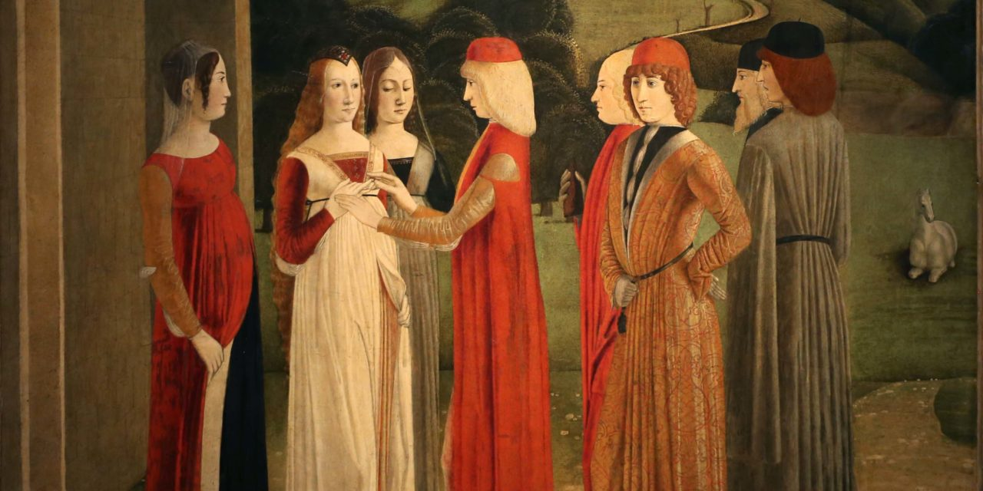
AL - Vojsava
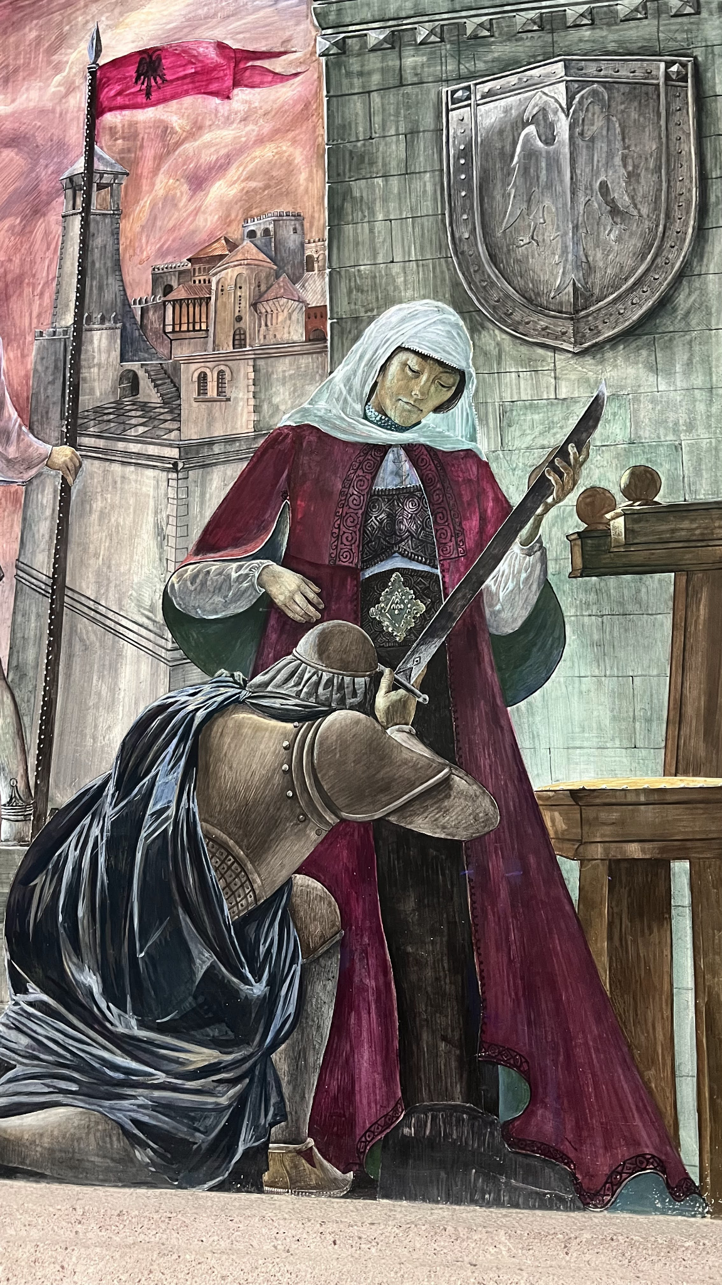
NM - Marija

Person in charge: Adisa Vatreš
Date for final delivery: 30.05.2023. - Done
Sketch

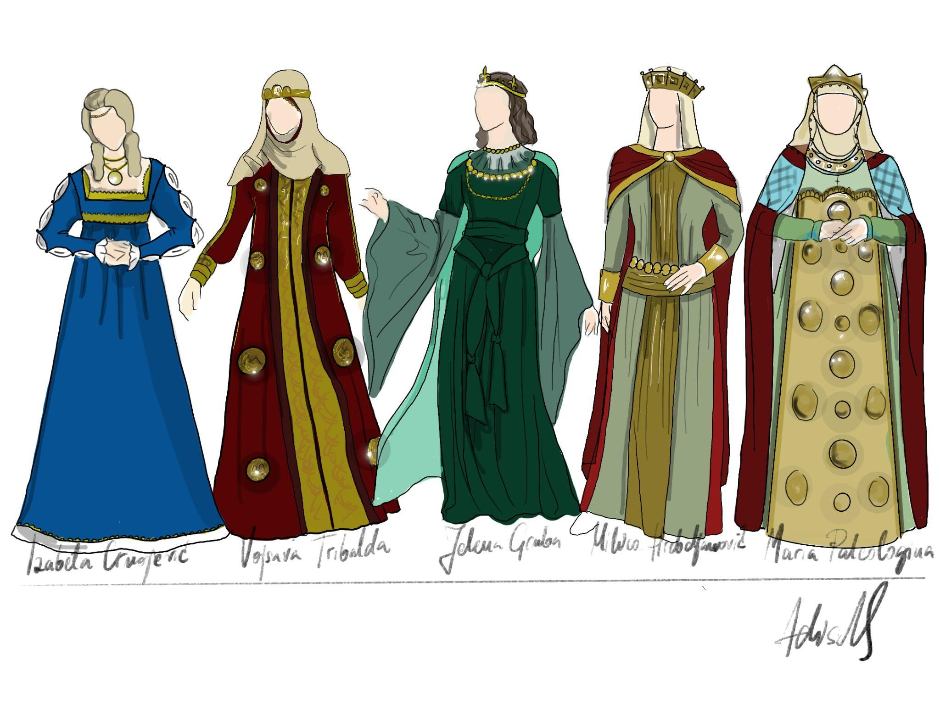
update for Milica and Jelena
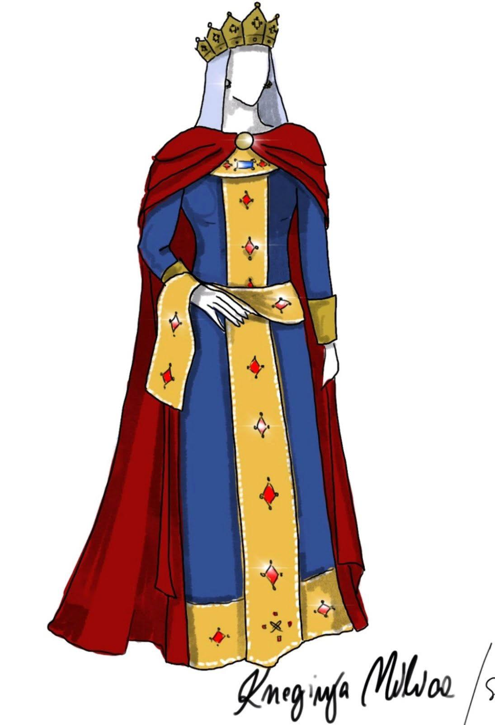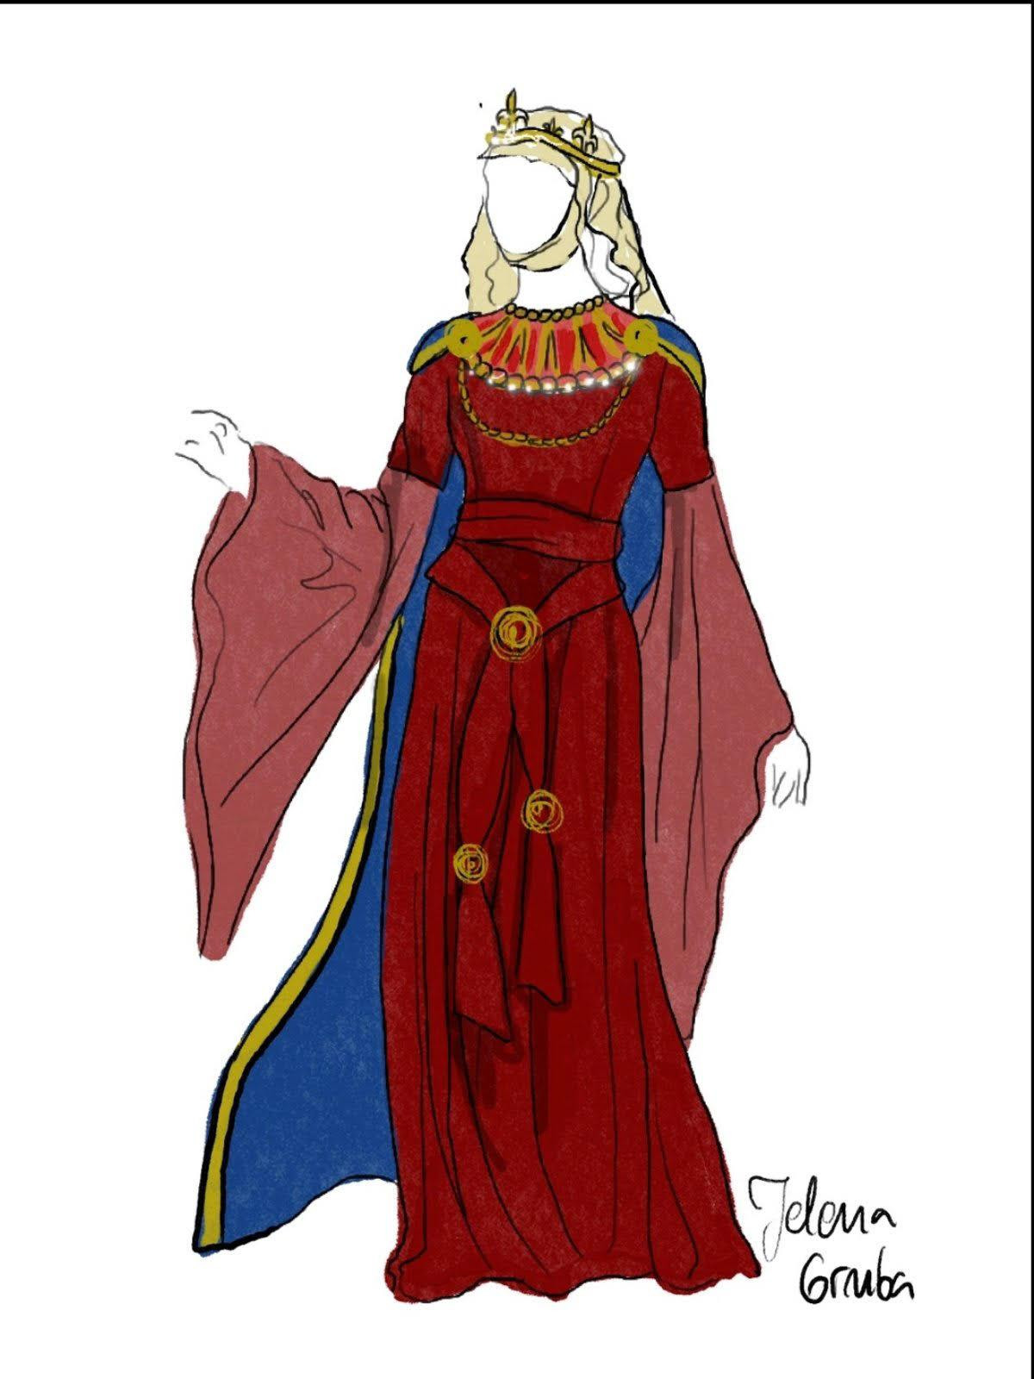

Technical section

This section will address all the technical elements needed in the final product of the application. These include: 3D modelling of main components, 3D modelling of additional items, Keying of the videos, Editing of the videos, Compositing of the videos, Audio postproduction; Music composing, Sound effects design, Programming, Additional Programming and crowd systems.
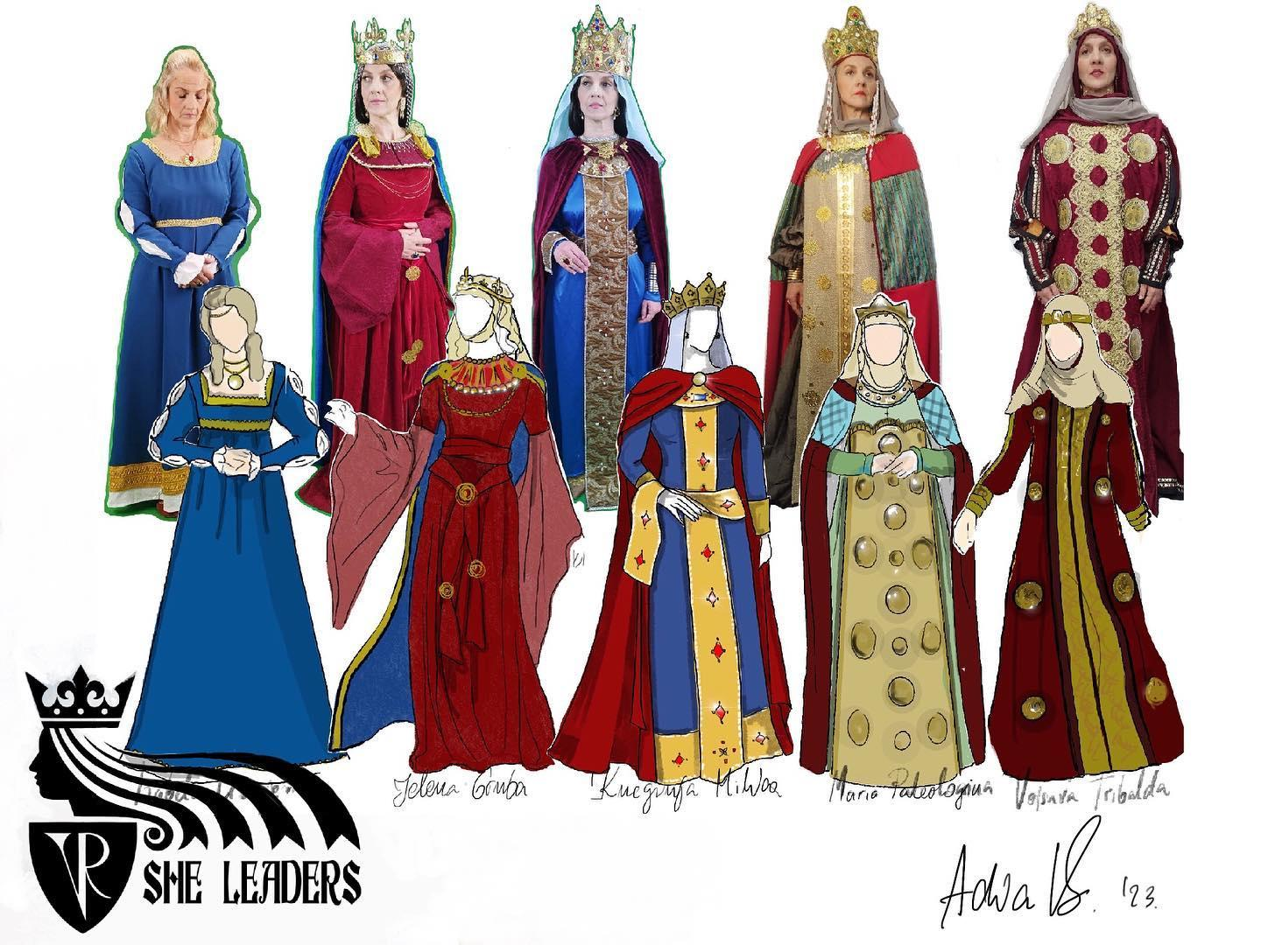

3D modelling of main components

Exact list of each item that needs to be modelled is listed below. Exact design of each item will be discussed with the experts from each location and if there is any suggestion, example or idea it can be added on the list below alongside that item.
- Starting room – Modeller: Edin D. – Status: STARTED
Remarks:
- Interior of collapsed tower in Serbia– Modeller: Edin D. – Status: DONE
Remarks:
- Exterior of collapsed tower in Serbia– Modeller: Edin D. – Status: DONE
Remarks:
- Interior of Palace in North Macedonia – Modeller: Aida – Status: DONE
Remarks:
- Exterior of Palace in North Macedonia – Modeller: Aida – Status: DONE
Remarks:
- Interior of small Basilica in Albania – Modeller: Aida – Status: DONE
Remarks:
- Exterior of small Basilica in Albania with countryside around it – Modeller: Aida – Status: DONE
Remarks:
- Interior of old Monastery with big hallway and two small rooms (Baptism room and printing press room) for Montenegro – Modeller: Festa – Status: DONE
Remarks:
- Exterior of old Monastery with stone plate inside its walls in Montenegro – Modeller: Festa – Status: DONE
Remarks:
- Interior of Bobovac castle with one additional Queen’s room for BiH – Modeller: Festa – Status: DONE
Remarks:
- Exterior of Bobovac castle for BiH – Modeller: Festa – Status: STARTED
Remarks:
- Final room – Modeller: Edin D. – Status: STARTED
Remarks:
- Custom controllers for the application - Status: DONE
Remarks:
- Bell from Albania – Modeller: Aida – Status:DONE
Remarks:
- Coins from Albania – Modeller: Aida – Status: DONE
Remarks:
- Printing press machine – Modeller: Festa – Status: DONE
Remarks:
- Capitel from Montenegro – Modeller: Festa – Status: DONE
Remarks:
- Documents about trading in Bosnia – Modeller: Festa – Status: STARTED
Remarks:
- Stone chair of Queen Helena – Modeller: Festa – Status: DONE
Remarks:
- Cup from Serbia – Modeller: Edin D. – Status: Photogrammetry model done
Remarks:
- Knife from Serbia– Modeller: Edin D. – Status: DONE
Remarks:
- Earring from Serbia– Modeller: Edin D. – Status: DONE
Remarks:
- Tombstone from North Macedonia – Modeller: Aida – Status: DONE
Remarks:
- Ritual object in church from North Macedonia – Modeller: Aida – Status: DONE
Remarks:

3D modelling of additional items

Alongside these main items, additional modelling of small items will be needed. These items can be modelled, bought or downloaded for free. They will be used as recurring items during gameplays. Bellow is the list:
- Mediaeval door model
- Different size cups
Person in charge: Aya
Link to additional 3D model of items: Additional 3D model items - SheLeaders
Date for final delivery: 01.09.2023.

Keying of videos

Videos of the actress need to be prepared for compositing. After finishing the shooting of the videos, videos will be exported with alpha background.
Person in charge: Festa
Date for final delivery: 01.09.2023.

Editing of videos

360° videos recorded need to be edited and sequence of videos made as preparation for compositing. During the editing process colouring of the video clips will be done.
Person in charge: Festa
Date for final delivery: 01.09.2023.

Compositing of videos

After keying and editing is finished, cinematics will be made through superimposing actress clips and 3D objects into the 360° videos. Final product will be complete cinematic that can now be sent to audio postproduction.
Person in charge: Festa
Date for final delivery: 15.09.2023.

Audio postproduction of videos

Once videos are produced, audio postproduction needs to be completed. During this process audio localization will be done, as well as adding of the music needed in the cinematics. End product will be a finished audio sequence which will now be connected to the video final. These files will be considered the final video clips and will be used in the application.
Status: DONE
Person in charge: Dado
Date for final delivery: 15.10.2023.

Music composing

Several music themes should be produced for the application. Below is the list of all musical themes needed as well as examples on what they could be based on.
0. Language selection menu music loop. Status: DONE Filename: musicLanguageMenu_loop_v*.wav
- Intro music loop – Used in splash screen. Status: DONE Filename: musicIntroSplash_loop_v*.wav
- Intro animation music – Used during intro animation. Status: DONE Filename: musicCinematicVO_v*.wav
- Starting room music loop – Used in the starting room. Status: DONE Filename: musicStartingRoom_loop_v*.wav
- BiH music – Used during BiH cinematic. Status: DONE Filename: musicStoryBiH_v*.wav
- Serbia music – Used during Serbia cinematic. Status: DONE Filename: musicStorySerbia_v*.wav
- North Macedonia music – Used during North Macedonia cinematic. Status: DONE Filename: musicStoryNorthMacedonia_v*.wav
- Albania music – Used during Albania cinematic. Status: DONE Filename: musicStoryAlbania_v*.wav
- Montenegro music – Used during Montenegro cinematic. Status: DONE Filename: musicStoryMontenegro_v*.wav
- Gameplay music loop A – Used during gameplay parts of application. Status: DONE Filename: musicGameplayA_loop_v*.wav
- Gameplay music loop B – Used during gameplay parts of application. Status: DONE Filename: musicGameplayB_loop_v*.wav
- Gameplay music loop C – Used during gameplay parts of application. Status: DONE Filename: musicGameplayC_loop_v*.wav
- Congratulations music – Used when a player passes through the final door. Status: DONE Filename: musicCongratulations_v*.wav
- End music loop – Used after the “Congratulations music” Status: DONE Filename: musicFinalRoom_loop_v*.wav
- Exit music loop - Used when a player is about to leave the application. Status: DONE Filename: musicExit_loop_v*.wav

Person in charge: Dado
Date for final delivery: 01.09.2023.

Sound effects design

Sound effects will be required for both gameplay and storytelling parts. This part will require recording of folly sounds and adding them to the application. Sounds like: wind, birds, footsteps, cup falling, door opening, door closing, etc.
Status: DONE
Person in charge: Dado
Date for final delivery: 01.11.2023.

Programming

This section will deal with the whole Unity design and programming of the application. Application tree will be listed below. User will open the application and the intro screen will display. Intro music loop will play. After pressing start, intro animation will play and intro animation music will go in the background. Afterwards the user will appear in the starting room from where he/she can access each country. Starting room music loop will play in the background. In each country 360 video sequence will play first with corresponding music background, and then gameplay part will load. Gameplay music loop 1 or 2 will play in the background. After finishing each part, the user will return to the starting room. After all 5 are completed, the user can enter the final corridor where Congratulations music will play and a message will appear to congratulate the user. After the message closes, the end music loop will play and the user can freely explore the final room. After going through the final door that reads “Return to the present” end credits splash will appear.
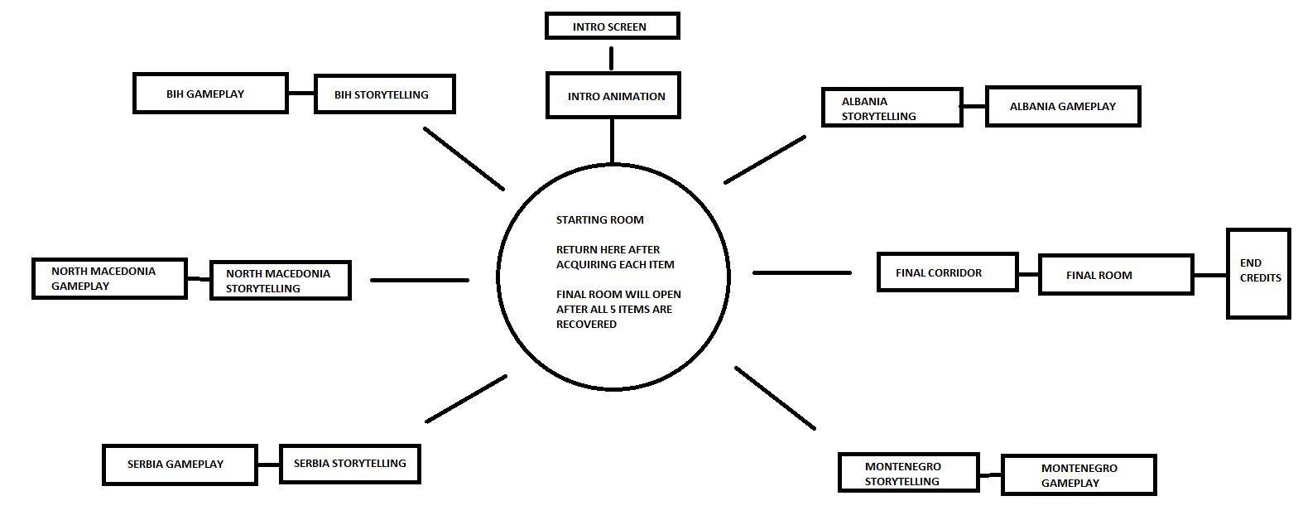

Storytelling part of programming

This part will include programming of intro screen and intro animation and buttons in them as well as end credits splash screen and buttons on it. These three scenes are described in the first section of this document. Each country's 360° video cinematic will also need to be programmed by adding pre-rendered videos in the Unity scenes and adding skip buttons.
Person in charge: Aya
Date for final delivery: 01.11.2023.

Subtitles in Unity

After adding each video into Unity, subtitles will also have to be added for each language.
Person in charge: Aya
Date for final delivery: 01.12.2023.

Gameplay part of programming

This part will include programming of Starting room, Final corridor and final room as well as each gameplay part of the application in each country. Description of these three rooms is explained in “APPLICATION DESIGN” chapter of this document and the scenario for each gameplay part is described in the “SECTION DESIGN” chapter of this document. Gameplays will be solvable in less than a minute if the user is familiar with all the aspects of the gameplay which should realistically provide 2-4 minutes of game time per each country.
In each gameplay there will be a number of side items added which the user will be able to pick up. Each of those items should have a sound effect added to it. There will also be scripted events happening in gameplays as well as object items which the user can interact with. Gameplays will be populated by crowd system NPCs as well as some intractable NPCs. User will have special ability to shift his view between VR headset cameras and 3D environment and will have to use that ability to finish gameplay. Passing through walls should not be allowed and as soon as a user steps into a wall, the whole screen should go dark and display the message “RETURN TO PLAY AREA”. There should also be an additional “MENU” button in which there will be three additional options: “Restart level”, “Help”, “Exit gameplay”. Restart level shall run the gameplay from the start while exit gameplay will return the user to the starting room. Help will display the controllers and buttons.
After finishing each gameplay, the user will return to the starting room, and items found will be now placed on the middle pedestal. However if the user presses the “Exit gameplay” button, gameplay is not solved and the item should not be there.
Programmers will work closely with ART DEPARTMENT in creating lighting for each game environment. This will help achieve better results and split work evenly. Team in charge of this part will also wrap up the whole application and export it for the target platform.
NOTE: There should be an “Easter egg” lever hidden in Starting room which opens the last door and solves the game immediately. It will be used as a debugging tool, game’s Easter egg feature, and for presentations of the application.
Person in charge: Edo & Tibor
Date for final delivery: 01.12.2023.

UX programming

The UX part of the application will be a custom made experience. Controllers will not mirror each other and instead will behave differently Movement will be available with both teleport and joystick. Left controller will be used for movement, and the right controller for interacting.
Left controller will have a custom 3D model, and the “TRIGGER” button will be used for teleporting. If possible, teleport should have a cool down effect before using it again. It should be not more than two seconds. Graphical arrow will be used to point where the user will teleport. If possible “dash-like” animation should be applied to the teleport. “JOYSTICK” will be used for moving around and the movement should be done more realistically like “Journey of Gods VR” or similar. “X” button will be a special ability button which changes the environment look from a 3D model to Oculus cameras where the user can see a real life room and hidden 3D object that needs to be found. “GRAB” button should be used for grabbing items on both controllers in the same way. To grab an item you should approach it so the snapping should not be available. “Y” button will be used for opening additional menus in gameplays.
Right controller will have a custom 3D model, and the “TRIGGER” button will be used for interacting with the objects and buttons. “JOYSTICK” should be used for scrolling of the texts if needed. “A” button on the controller will be used for opening the additional game menu. “GRAB” button should be used for grabbing items on both controllers in the same way. To grab an item you should approach it so the snapping should not be available. “B” button will be used for opening additional menus in gameplays.
Person in charge: Edo & Tibor
Date for final delivery: 01.12.2023.

Additional programming

Anything related to the programming which was not specifically addressed in previous sections should go under this section. This can include scripting of items, helping with object placement, scripting of NPCs, etc.
Person in charge: Davud
Date for final delivery: 01.12.2023.

Crowd simulation system

Gameplay parts of the application should be populated by a crowd simulation system. Characters appearing in gameplay should be mediaeval townsfolk, priests and knights strolling around the environment. Few of these characters should be real NPCs you can interact with. Some of them will be a part of the quest the user needs to achieve. All of these should be implemented into gameplay scenes in coordination with gameplay programmers.
Person in charge: Fedja
Date for final delivery: 01.11.2023.

AR Application overview

The Augmented Reality (AR) application will be created to encourage people visiting the historical locations in Western Balkans to learn about their cultural importance and visit nearby museums/heritage organisations to learn more. The users will download the mobile application via the App Store (iOS) or the Play Store (Android) for free. On location, they can view and interact with the 3D-modelled environment in Augmented Reality. Each location will also include a video of an actress narrator telling a story about the selected queen in the Balkans from medieval times. The application will be accessible in English and local languages: Bosnian, Serbian, Montenegrin, Albanian and Macedonian.

AR Application design

The AR application will reuse some of the content created for the Virtual Reality experience, e.g. 3D models and videos of the narrators. The design of the application will use the SHELeadersVR project’s colours, fonts, graphics and overall medieval “look and feel”, but will have its own distinct style as a standalone AR experience.

The Wireframe

Wireframes provide a visual roadmap for AR app designers and developers. They help clarify the app's structure, user interactions, and visual elements in a concise manner. For AR apps, which blend digital content with the physical world, this is pivotal in ensuring a seamless and engaging user experience.
The wireframe was created using Miro - a visual workspace and digital collaboration platform: https://miro.com/app/board/uXjVMwnYrMY=/ It sets out the three key elements of the application:
- Layout and arrangement of the interface elements on each screen;
- Interface elements such as input controls (buttons), navigational components (heading, menu, icons) and informational components (text, images, map);
- Navigation system demonstrating how users move through the app.
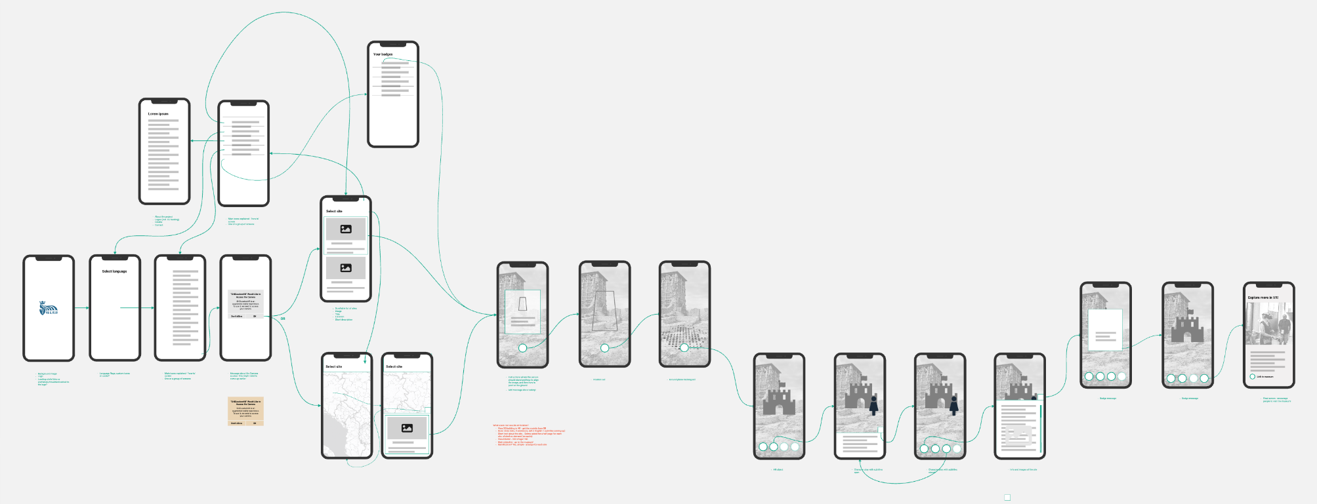AR application - wireframe

The first ten screens in the wireframe refer to the non-AR parts of the application such as: Splash screen, Language selection, Onboarding/help, Menu, About, Camera permission/access, Site list, Badges, Map, Map with a selected site.

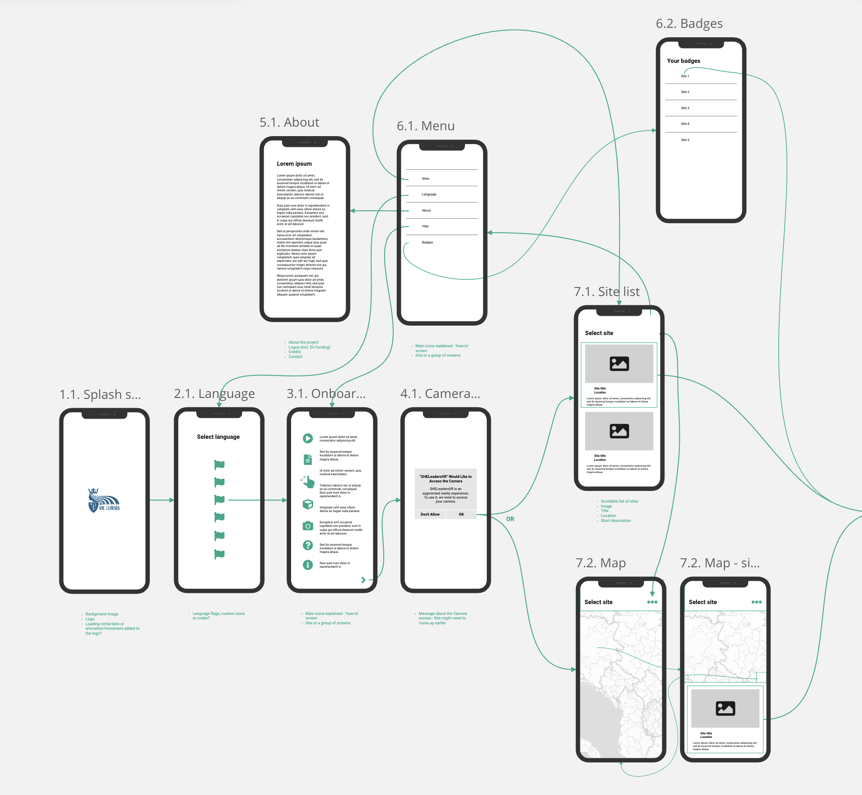
AR application - wireframe - non-AR screens

The following ten screens outlay the AR experience and include elements such as: Instructions, Positioning, Ground plane-tracking, AR view, Character view, Site info, Badge, and More information.

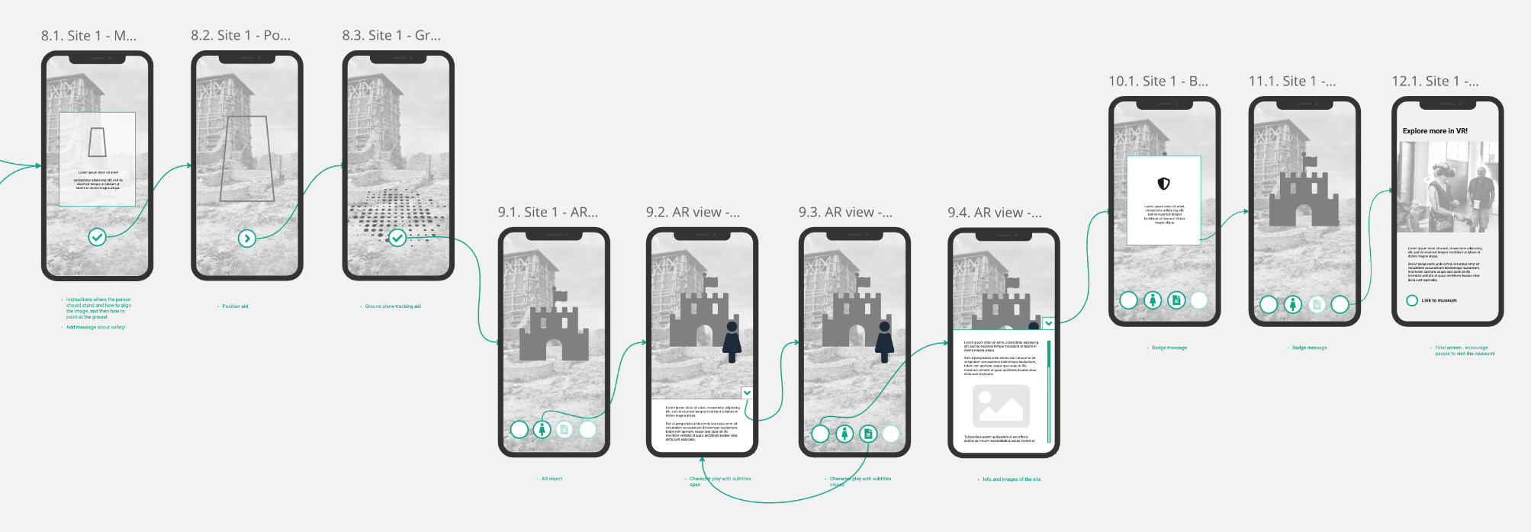
AR application - wireframe - AR screens

Person in charge: Karolina Badz
Date for final delivery: 03.08.2023

UI design

The UI design includes the visual “look and feel” of the experience and all the necessary interfaces and content, ensuring the app is not just technologically advanced, but also accessible, enjoyable, and effective. The design was created in Adobe XD - a vector design tool for web and mobile applications and imported to Miro for review.
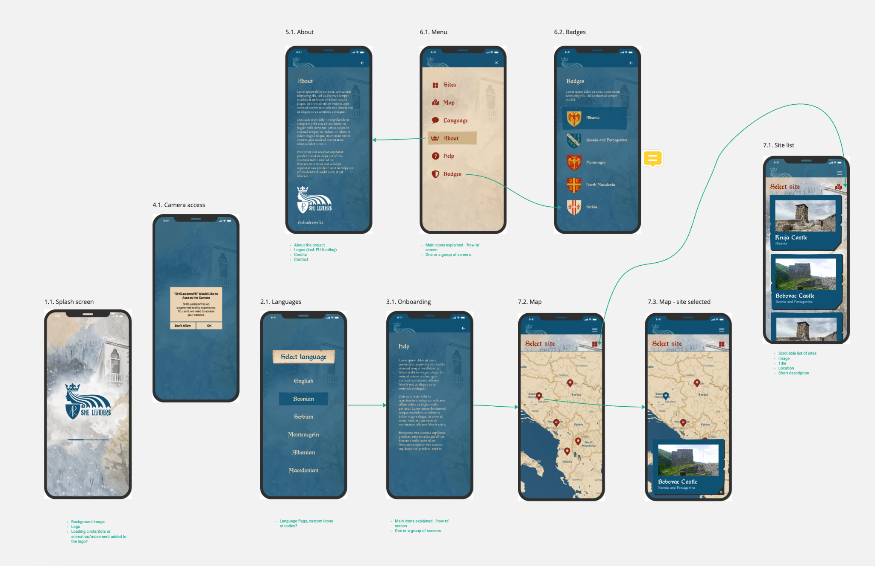
AR application - design of non-AR screens
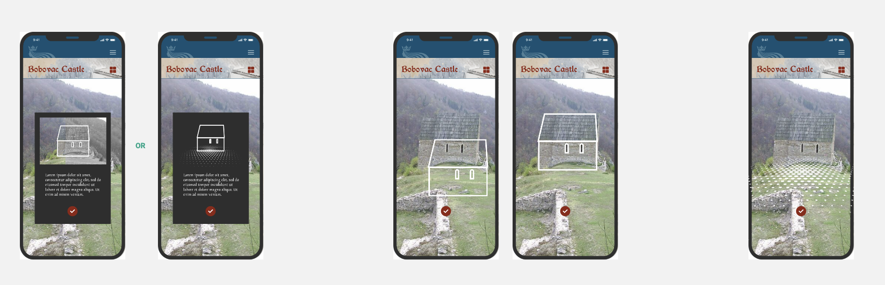
AR application - design of AR screens

Colours
The colour palette chosen for the AR application used the SHELeadersVR project colours as a base and includes the following colours: beige, blue, light blue, charcoal, red, white, and yellow. To conform with accessibility standards, an accessible colour combinations guide was created using the Accessible Color Matrix tool (https://toolness.github.io/accessible-color-matrix/).

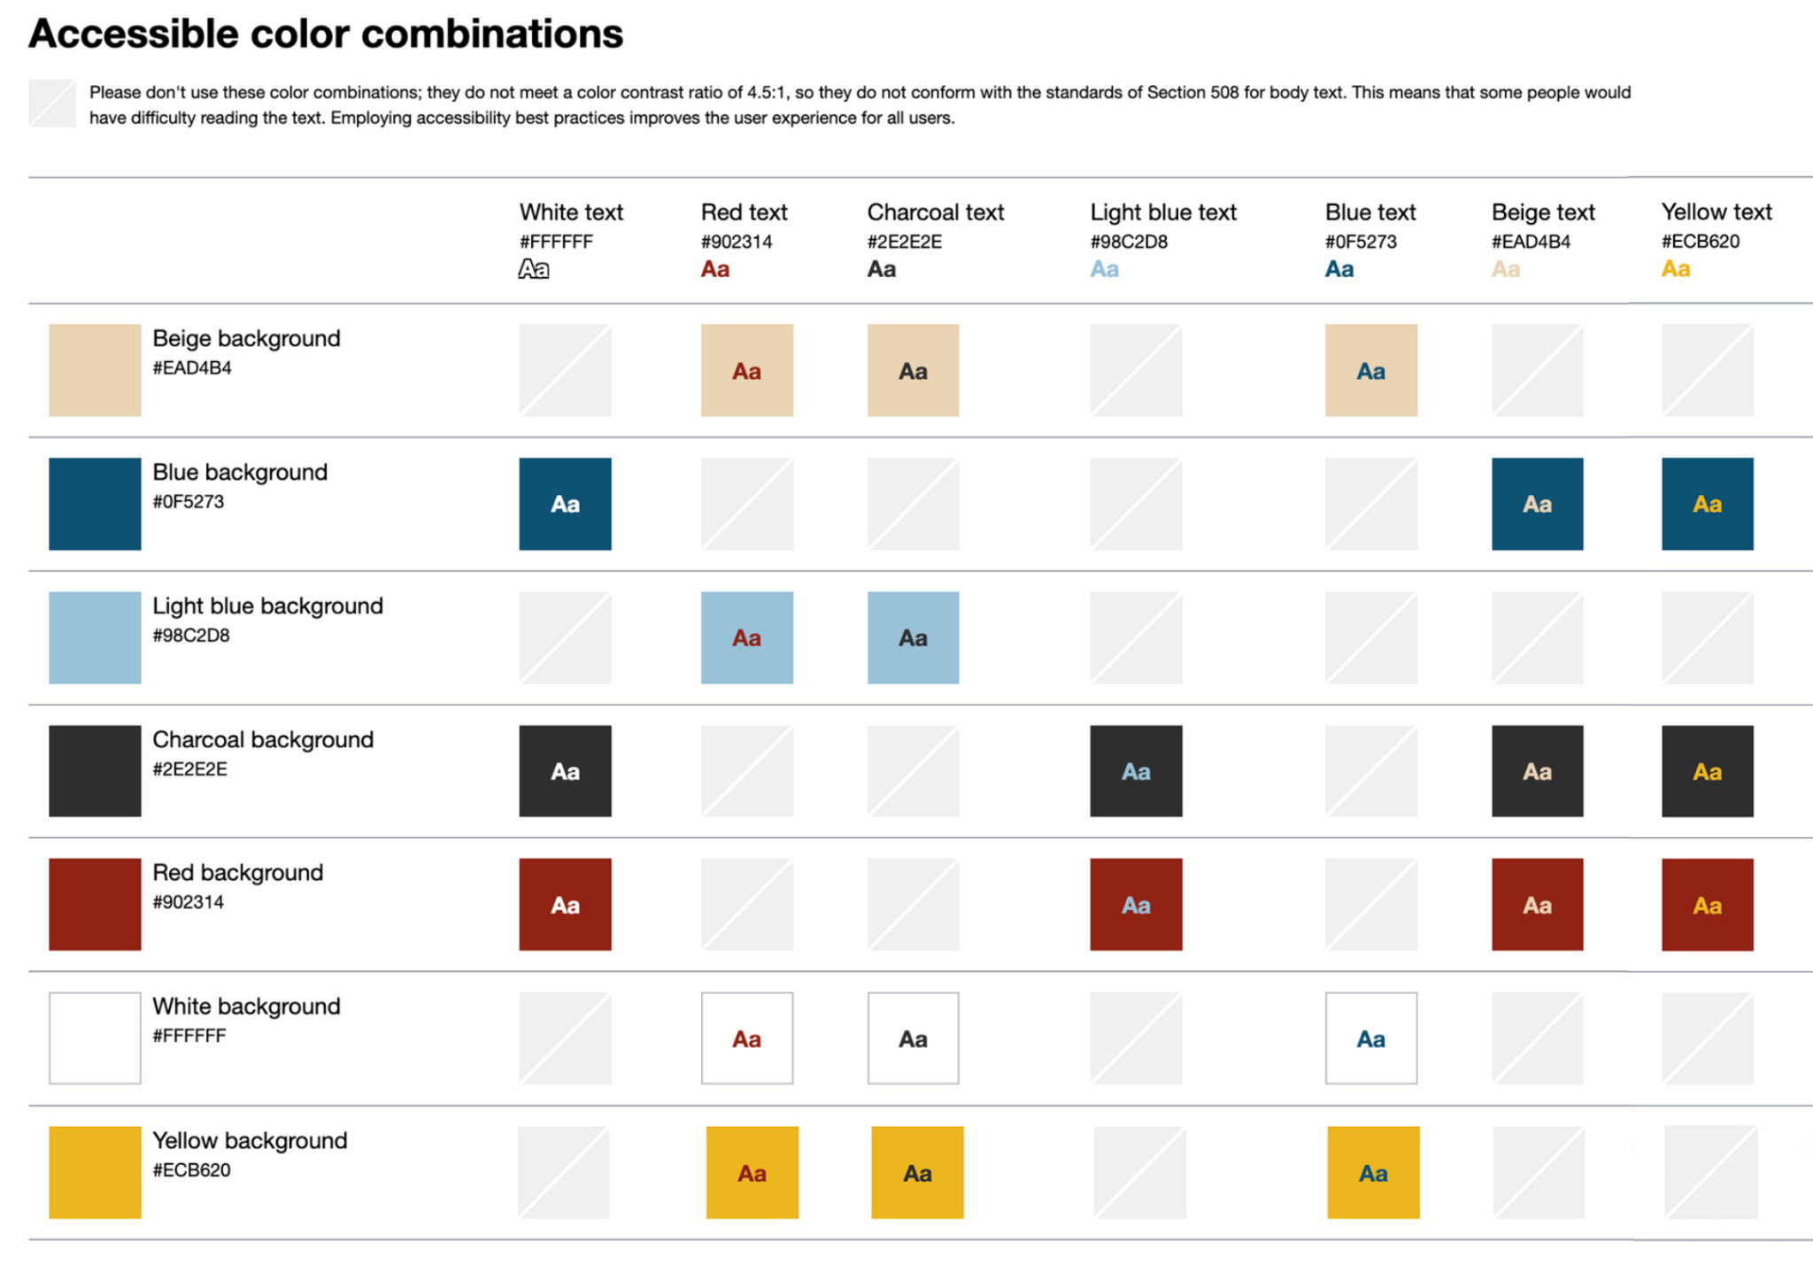AR application - colour palette

Fonts
The AR application uses two “medieval” style fonts selected by the project team: Goudament Regular and Morris Roman Bold. For system messages, such as the Camera permission/access, a sans serif typeface Inter will be used unless overwritten by the default system font (Roboto in Android, and SF Pro in iOS).
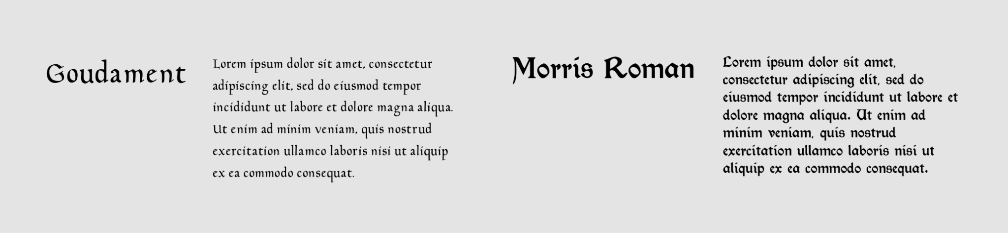AR application - fonts

Logo
For the purpose of the AR application, a custom logo was created by the project team to include “AR” in it (instead of VR).

AR application - logo

Background graphic
The background image uses the graphic from the SHE Leaders VR project web page: https://sheleadersvr.ba/

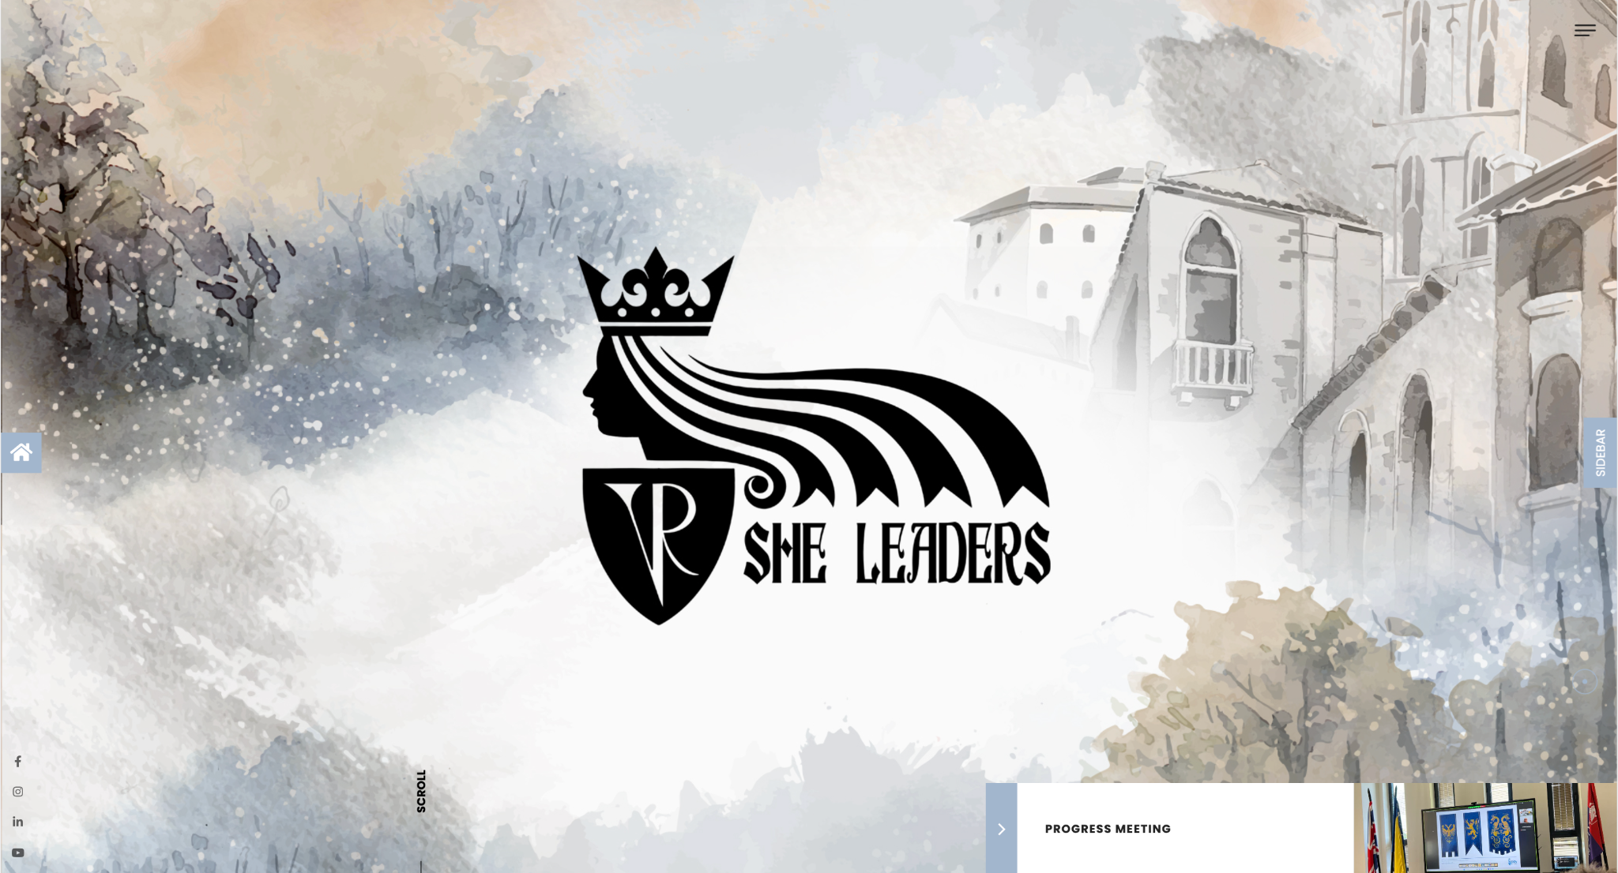
AR application - background graphic

Buttons
The buttons, as well as highlights and card elements, e.g. selected Menu items, sites, are in the style of old parchment.

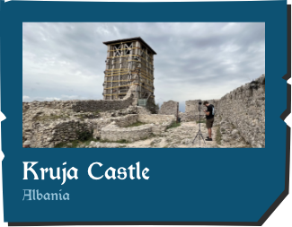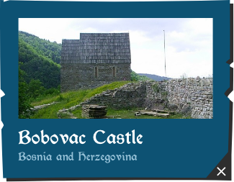
AR application - buttons, highlights, cards

Icons
The icons used across the AR application are simple in style in order to clearly communicate their meaning and help navigation.


AR application - icons

Map
To add

Badges
To add

Images
To add

AR elements
To add

3D model
To add

Videos
To add

Person in charge: Karolina Badz
Date for final delivery: 29.11.2023

AR Application build

Person in charge: Klemens Kopetzky
Date for final delivery:

