Supplemental Materials
Transparent Risks Revisited: Evidence for a Dark-is-More Bias in Risk Perception

Laura E. Matzen
Sandia National Laboratories

In the following sections, we provide larger examples of the stimuli, the results of the text versus visualization comparisons in each experiment, and the full details of the statistical tests presented in the paper. The full set of stimuli used in the experiments are available at https://osf.io/cmdbt/ and the code used to run the studies on Amazon Mechanical Turk is available upon request to lematze@sandia.gov.

Experiment 1 Stimuli
Conditions: text, high risk = dark (with or without salient borders), high risk = light (with or without salient borders). The text and high risk = dark stimuli were identical to those used in Matzen et al., 2024. Note how the same combinations of a distinct background map and overlay shape repeat along the diagonal in this figure. These stimuli were divided into counterbalanced lists so that one participant saw the map stimuli in the first column, a different participant saw the map stimuli in the second column, etc. All participants saw the same set of text stimuli.
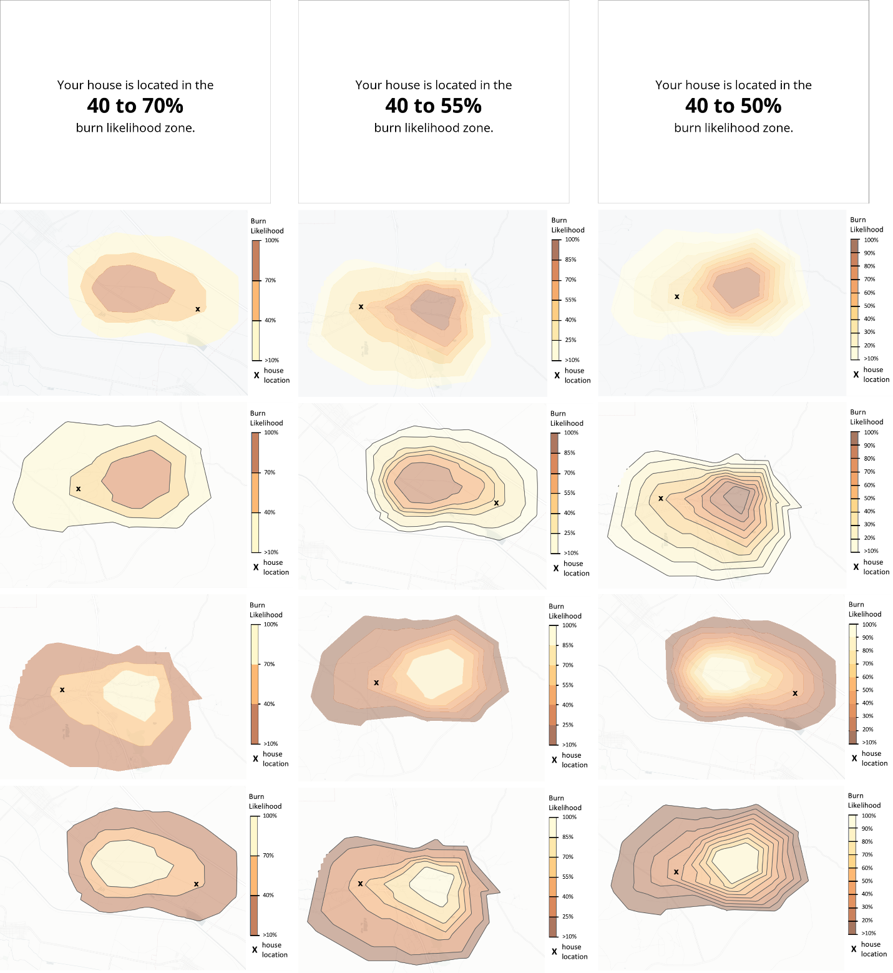
High risk = light, borders
High risk = light, no borders
High risk = dark, borders
High risk = dark, no borders
Text
Experiment 2 Stimuli
Conditions: text, Tiger1 Light Map (innermost band lighter), Tiger2 Light Map (innermost band darker). Only the medium- and high-specificity (six and nine probability bands) were used in Experiments 2 and 3. The map condition was a between-subjects variable, so each participant only saw Tiger1 or Tiger2 stimuli. All participants saw the same set of text stimuli. Note that for the Tiger1 stimuli, the outermost band was dark for the medium-specificity stimuli and light for the high-specificity stimuli. The opposite was true for the Tiger2 maps.
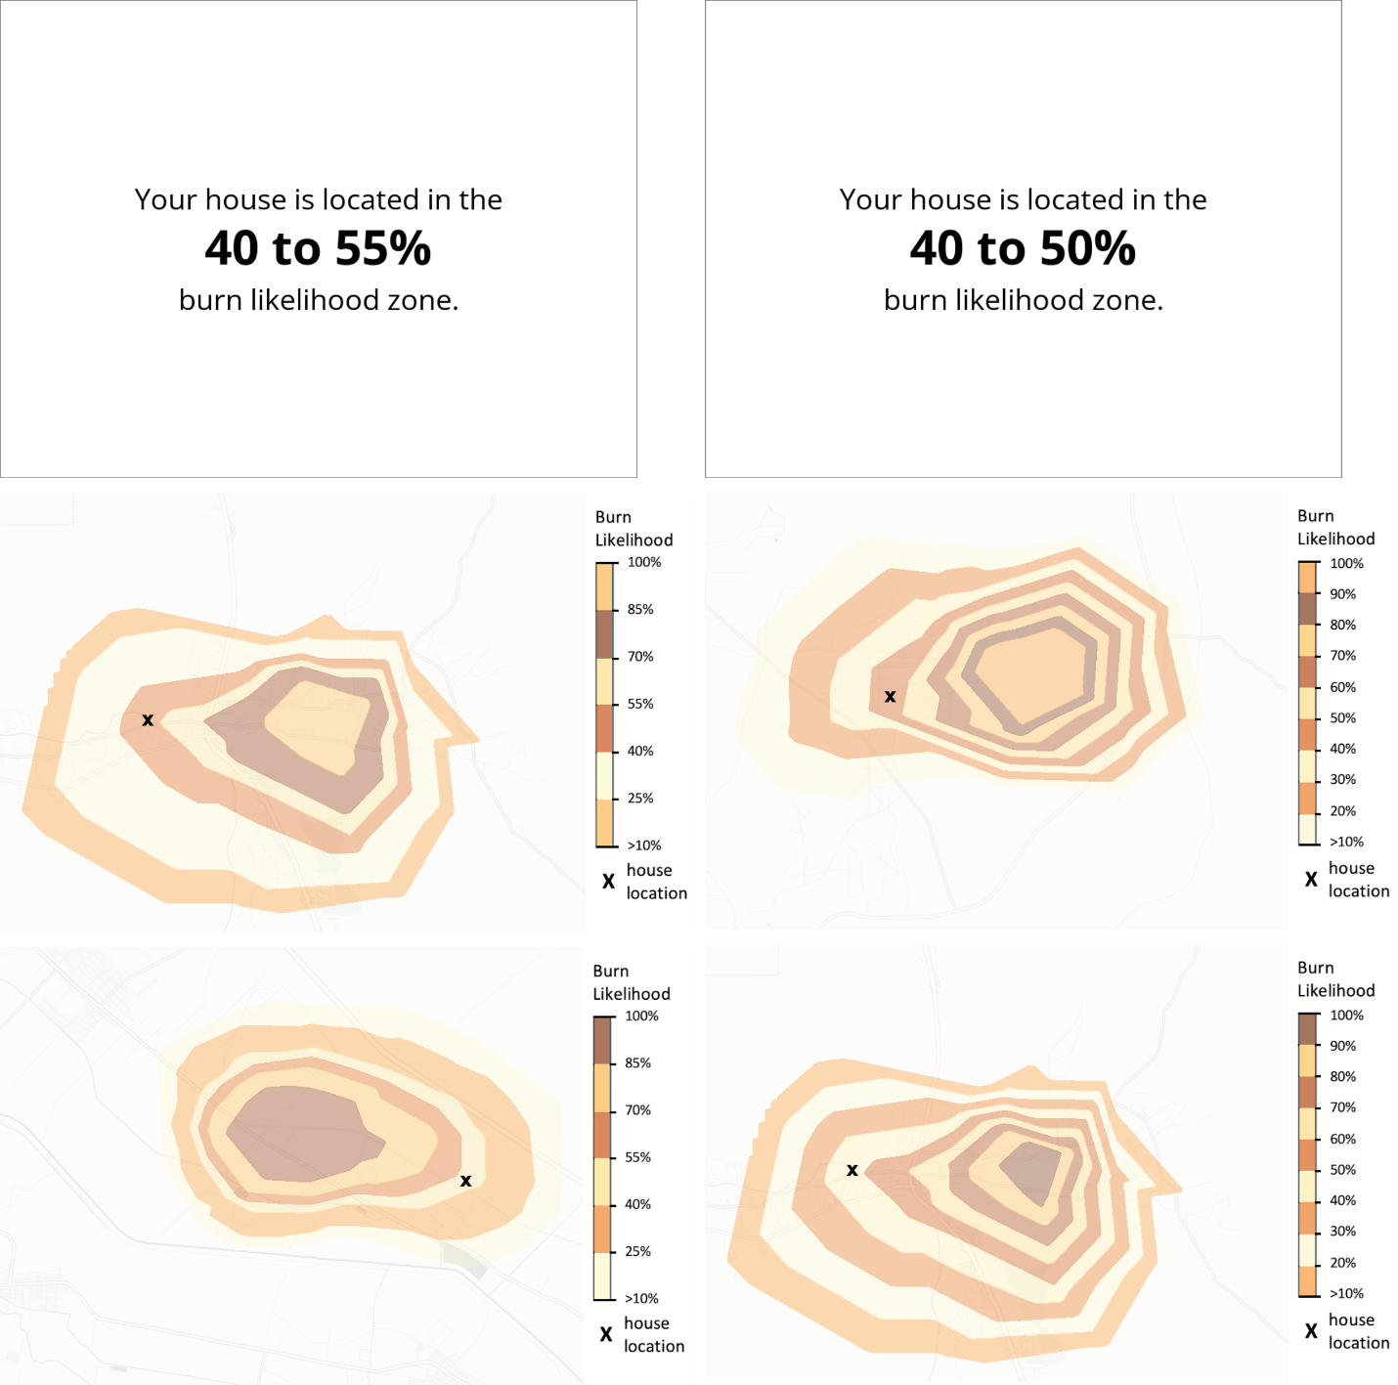
Text
Tiger2
Tiger1

Experiment 3 Stimuli
Conditions: text, Tiger1 Dark Map (innermost band lighter), Tiger2 Dark Map (innermost band darker). The map condition was a between-subjects variable, so each participant only saw Tiger1 or Tiger2 stimuli. All participants saw the same set of text stimuli.
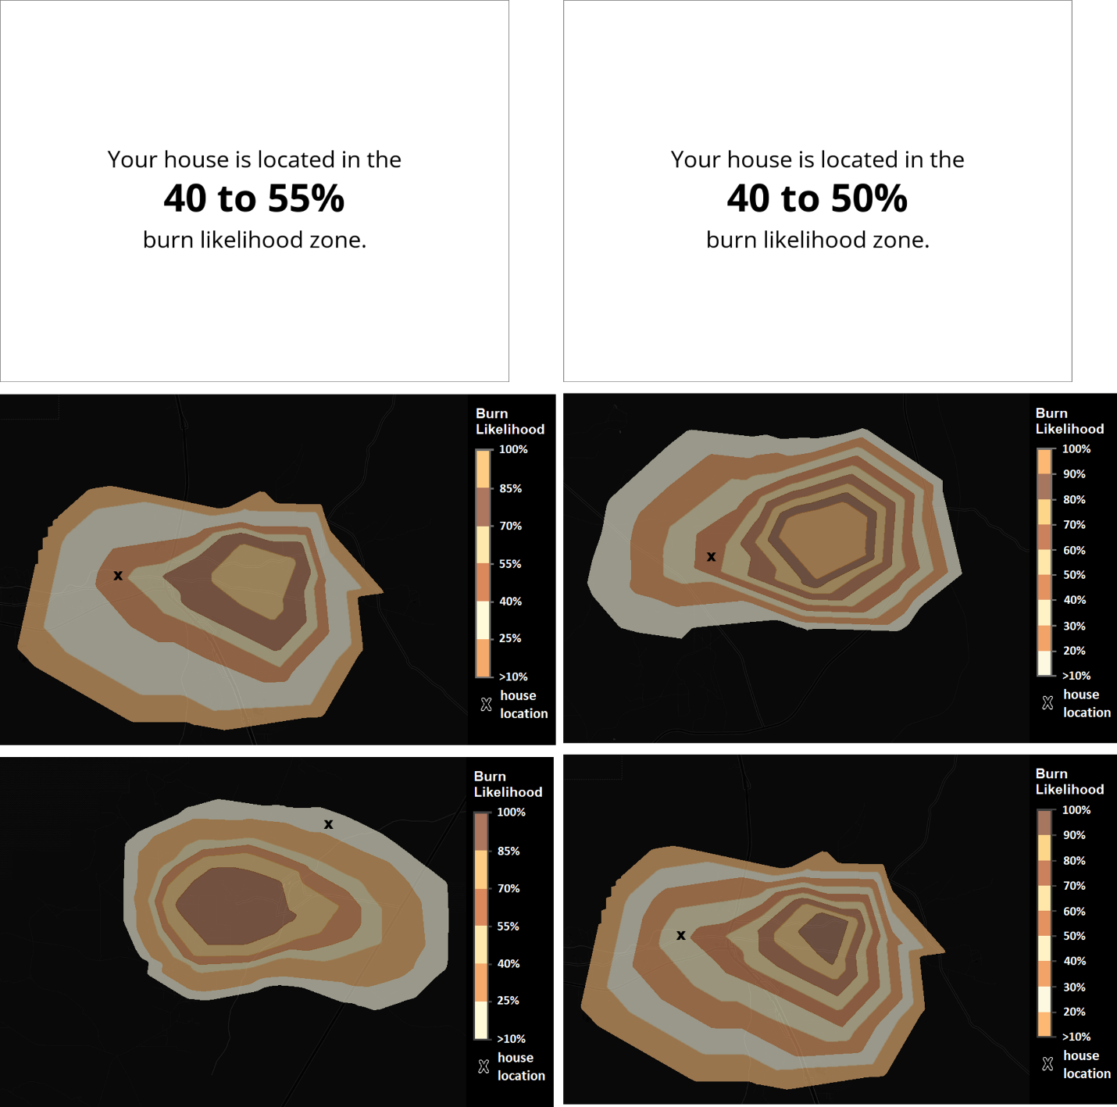
Text
Tiger1
Tiger2

Comparisons of the Text and Visualization Stimuli
In all three experiments, the evacuation rates were significantly higher for text than for visualizations. This is consistent with our prior work, where participants tended to base their judgements about the text stimuli on the higher number in the range (i.e., the 50% probability in a 40-50% range). In the map stimuli, they tended to modulate their decisions based on the relative position of the house within the probability band, with lower evacuation rates when the house was closer to the outer edge of the band (Matzen et al., 2024).
In Experiments 1 and 2 of the present study, the evacuation rates for visualizations were significantly lower than the evacuation rates for text in all of the specificity conditions. In Experiment 3, the version with the dark map backgrounds, the participants had higher overall evacuation rates for the visualizations. In that case, there was still a main effect of information type (visualization or text), but the post-hoc tests did not show significant differences when looking only at the medium- or high-specificity stimuli. The information about the statistical tests is provided below.
Experiment 1: Visualization versus Text Analysis
Results of 2x3 (information type x specificity) repeated measures ANOVA:
Effect | DFn | DFd | F | p | p<.05 | generalized eta squared
VisOrText | 1 | 95 | 59.985 | 1.03E-11 | * | 0.067
NumBands | 2 | 190 | 20.411 | 9.34E-09 | * | 0.026
VisOrText:NumBands | 2 | 190 | 6.711 | 0.002 | * | 0.007

Pairwise t-tests with Bonferroni correction:
Comparing text to visualizations within each specificity level:
NumBands | .y. | group1 | group2 | n1 | n2 | p | p.signif | p.adj | p.adj.signif
3 | Evac | Text | Vis | 96 | 96 | 0.0367 | * | 0.0367 | *
6 | Evac | Text | Vis | 96 | 96 | 1.70E-05 | **** | 1.70E-05 | ****
9 | Evac | Text | Vis | 96 | 96 | 1.03E-05 | **** | 1.03E-05 | ****

Experiment 2: Visualization versus Text Analysis
Results of 2x3 (information type x specificity) repeated measures ANOVA:
Effect | DFn | DFd | F | p | p<.05 | generalized eta squared
VisOrText | 1 | 59 | 18.703 | 5.97E-05 | * | 0.050
NumBands | 1 | 59 | 6.110 | 1.60E-02 | * | 0.006
VisOrText:NumBands | 1 | 59 | 1.939 | 1.69E-01 |  | 0.002

Pairwise t-tests with Bonferroni correction:
Comparing text to visualizations within each specificity level:
NumBands | .y. | group1 | group2 | n1 | n2 | p | p.signif | p.adj | p.adj.signif
6 | Evac | Text | Vis | 60 | 60 | 0.0255 | * | 0.0255 | *
9 | Evac | Text | Vis | 60 | 60 | 0.00766 | ** | 0.00766 | **

Experiment 3: Visualization versus Text Analysis
Results of 2x3 (information type x specificity) repeated measures ANOVA:
Effect | DFn | DFd | F | p | p<.05 | generalized eta squared
VisOrText | 1 | 59 | 4.090 | 0.048 | * | 0.010
NumBands | 1 | 59 | 7.957 | 0.007 | * | 0.006
VisOrText:NumBands | 1 | 59 | 1.048 | 0.310 |  | 0.001

Pairwise t-tests with Bonferroni correction:
Comparing text to visualizations within each specificity level:
NumBands | .y. | group1 | group2 | n1 | n2 | p | p.signif | p.adj | p.adj.signif
6 | Evac | Text | Vis | 60 | 60 | 0.515 | ns | 0.515 | ns
9 | Evac | Text | Vis | 60 | 60 | 0.121 | ns | 0.121 | ns

Analyses of the Visualization Conditions
Experiment 1: Comparison of the Visualization Conditions
Results of 2x2x3 (color scale x border lines x specificity) repeated measures ANOVA:
Effect | DFn | DFd | F | p | p<.05 | generalized eta squared
ColorOrder | 1 | 95 | 17.813 | 5.58E-05 | * | 0.019
Border Lines | 1 | 95 | 0.2 | 0.656 |  | 9.99E-05
NumBands | 2 | 190 | 42.475 | 5.65E-16 | * | 0.043
ColorOrder:Lines | 1 | 95 | 38.496 | 1.42E-08 | * | 0.015
ColorOrder:NumBands | 2 | 190 | 12.24 | 1.00E-05 | * | 0.009
Lines:NumBands | 2 | 190 | 4.031 | 0.019 | * | 0.003
ColorOrder:Lines:NumBands | 2 | 190 | 8.023 | 0.000452 | * | 0.005

Pairwise t-tests with Bonferroni correction:
Comparing the two color scales:
.y. | group1 | group2 | n1 | n2 | p | p.signif | p.adj | p.adj.signif
Evac | Low Risk Darker | Low Risk Lighter | 576 | 576 | 5.32E-06 | **** | 5.32E-06 | ****

Comparing the specificity levels:
.y. | group1 | group2 | n1 | n2 | p | p.signif | p.adj | p.adj.signif
Evac | 3 | 6 | 384 | 384 | 0.000532 | *** | 0.0016 | **
Evac | 3 | 9 | 384 | 384 | 3.91E-12 | **** | 1.17E-11 | ****
Evac | 6 | 9 | 384 | 384 | 0.000414 | *** | 0.00124 | **

Comparing the border lines vs. no border lines for each of the two color scales:
ColorOrder | .y. | group1 | group2 | n1 | n2 | p | p.signif | p.adj | p.adj.signif
Low Risk Darker | Evac | Lines | No Lines | 288 | 288 | 0.0124 | * | 0.0124 | *
Low Risk Lighter | Evac | Lines | No Lines | 288 | 288 | 0.00158 | ** | 0.00158 | **

Comparing the two color scales for each specificity condition:
NumBands | .y. | group1 | group2 | n1 | n2 | p | p.signif | p.adj | p.adj.signif
3 | Evac | Low Risk Darker | Low Risk Lighter | 192 | 192 | 0.801 | ns | 0.801 | ns
6 | Evac | Low Risk Darker | Low Risk Lighter | 192 | 192 | 0.000367 | *** | 0.000367 | ***
9 | Evac | Low Risk Darker | Low Risk Lighter | 192 | 192 | 4.92E-05 | **** | 4.92E-05 | ****

Comparing the two color scales for each specificity condition and border line condition:
Num Bands | Lines | .y. | group1 | group2 | n1 | n2 | p | p.signif | p.adj | p.adj.signif
3 | Lines | Evac | Low Risk Darker | Low Risk Lighter | 96 | 96 | 0.714 | ns | 0.714 | ns
3 | No Lines | Evac | Low Risk Darker | Low Risk Lighter | 96 | 96 | 0.489 | ns | 0.489 | ns
6 | Lines | Evac | Low Risk Darker | Low Risk Lighter | 96 | 96 | 0.454 | ns | 0.454 | ns
6 | No Lines | Evac | Low Risk Darker | Low Risk Lighter | 96 | 96 | 2.02E-05 | **** | 2.02E-05 | ****
9 | Lines | Evac | Low Risk Darker | Low Risk Lighter | 96 | 96 | 0.719 | ns | 0.719 | ns
9 | No Lines | Evac | Low Risk Darker | Low Risk Lighter | 96 | 96 | 3.47E-08 | **** | 3.47E-08 | ****

Experiment 2: Comparison of the Visualization Conditions
Results of 2x6 (map condition x risk band) ANOVA for the medium-specificity (six band) maps:
Effect | DFn | DFd | F | p | p<.05 | generalized eta squared
VisCond | 1 | 58 | 2.191 | 0.144 |  | 0.009
RiskBand | 5 | 290 | 154.071 | 1.88E-79 | * | 0.668
VisCond:RiskBand | 5 | 290 | 12.315 | 7.68E-11 | * | 0.139

Pairwise t-tests with Bonferroni correction:
Comparing the two map types within each risk band:
RiskBand | .y. | group1 | group2 | n1 | n2 | p | p.signif | p.adj | p.adj.signif
10-25% | Evac | tiger1 | tiger2 | 30 | 30 | 0.00965 | ** | 0.00965 | **
25-40% | Evac | tiger1 | tiger2 | 30 | 30 | 0.000625 | *** | 0.000625 | ***
40-55% | Evac | tiger1 | tiger2 | 30 | 30 | 0.000281 | *** | 0.000281 | ***
55-70% | Evac | tiger1 | tiger2 | 30 | 30 | 0.258 | ns | 0.258 | ns
70-85% | Evac | tiger1 | tiger2 | 30 | 30 | 0.00245 | ** | 0.00245 | **
85-100% | Evac | tiger1 | tiger2 | 30 | 30 | 0.00925 | ** | 0.00925 | **

Results of 2x9 (map condition x risk band) ANOVA for the high-specificity (nine band) maps:
Effect | DFn | DFd | F | p | p<.05 | generalized eta squared
VisCond | 1 | 58 | 0.559 | 0.458 |  | 0.002
RiskBand | 8 | 464 | 151.944 | 1.88E-79 | * | 0.672
VisCond:RiskBand | 8 | 464 | 10.064 | 5.63E-13 | * | 0.119

Pairwise t-tests with Bonferroni correction:
Comparing the two map types within each risk band:
RiskBand | .y. | group1 | group2 | n1 | n2 | p | p.signif | p.adj | p.adj.signif
10-20% | Evac | tiger1 | tiger2 | 30 | 30 | 0.0544 | ns | 0.0544 | ns
20-30% | Evac | tiger1 | tiger2 | 30 | 30 | 0.00253 | ** | 0.00253 | **
30-40% | Evac | tiger1 | tiger2 | 30 | 30 | 8.33E-05 | **** | 8.33E-05 | ****
40-50% | Evac | tiger1 | tiger2 | 30 | 30 | 0.168 | ns | 0.168 | ns
50-60% | Evac | tiger1 | tiger2 | 30 | 30 | 0.0033 | ** | 0.0033 | **
60-70% | Evac | tiger1 | tiger2 | 30 | 30 | 0.00784 | ** | 0.00784 | **
70-80% | Evac | tiger1 | tiger2 | 30 | 30 | 0.0716 | ns | 0.0716 | ns
80-90% | Evac | tiger1 | tiger2 | 30 | 30 | 0.035 | * | 0.035 | *
90-100% | Evac | tiger1 | tiger2 | 30 | 30 | 0.155 | ns | 0.155 | ns

Experiment 3: Comparison of the Visualization Conditions
Results of 2x6 (map condition x risk band) ANOVA for the medium-specificity (six band) maps:
Effect | DFn | DFd | F | p | p<.05 | generalized eta squared
VisCond | 1 | 58 | 1.978 | 0.165 |  | 0.009
RiskBand | 5 | 290 | 275.529 | 6.97E-108 | * | 0.78
VisCond:RiskBand | 5 | 290 | 5.209 | 0.000135 | * | 0.063

Pairwise t-tests with Bonferroni correction:
Comparing the two map types within each risk band:
RiskBand | .y. | group1 | group2 | n1 | n2 | p | p.signif | p.adj | p.adj.signif
10-25% | Evac | tiger1 | tiger2 | 30 | 30 | 0.331 | ns | 0.331 | ns
25-40% | Evac | tiger1 | tiger2 | 30 | 30 | 0.542 | ns | 0.542 | ns
40-55% | Evac | tiger1 | tiger2 | 30 | 30 | 0.00337 | ** | 0.00337 | **
55-70% | Evac | tiger1 | tiger2 | 30 | 30 | 0.566 | ns | 0.566 | ns
70-85% | Evac | tiger1 | tiger2 | 30 | 30 | 0.267 | ns | 0.267 | ns
85-100% | Evac | tiger1 | tiger2 | 30 | 30 | 0.0907 | ns | 0.0907 | ns

Results of 2x9 (map condition x risk band) ANOVA for the high-specificity (nine band) maps:
Effect | DFn | DFd | F | p | p<.05 | generalized eta squared
VisCond | 1 | 58 | 1.287 | 0.261 |  | 0.004
RiskBand | 8 | 464 | 228.178 | 1.63E-155 | * | 0.758
VisCond:RiskBand | 8 | 464 | 4.367 | 4.23E-05 | * | 0.057

Pairwise t-tests with Bonferroni correction:
Comparing the two map types within each risk band:
RiskBand | .y. | group1 | group2 | n1 | n2 | p | p.signif | p.adj | p.adj.signif
10-20% | Evac | tiger1 | tiger2 | 30 | 30 | 0.399 | ns | 0.399 | ns
20-30% | Evac | tiger1 | tiger2 | 30 | 30 | 0.361 | ns | 0.361 | ns
30-40% | Evac | tiger1 | tiger2 | 30 | 30 | 0.595 | ns | 0.595 | ns
40-50% | Evac | tiger1 | tiger2 | 30 | 30 | 0.00213 | ** | 0.00213 | **
50-60% | Evac | tiger1 | tiger2 | 30 | 30 | 0.3 | ns | 0.3 | ns
60-70% | Evac | tiger1 | tiger2 | 30 | 30 | 0.117 | ns | 0.117 | ns
70-80% | Evac | tiger1 | tiger2 | 30 | 30 | 0.179 | ns | 0.179 | ns
80-90% | Evac | tiger1 | tiger2 | 30 | 30 | 0.321 | ns | 0.321 | ns
90-100% | Evac | tiger1 | tiger2 | 30 | 30 | 0.179 | ns | 0.179 | ns

Comparison of Experiments 2 and 3:
Results of 2x2x2 (background color x band color x specificity) ANOVA comparing the maps used in Experiments 2 and 3:
Effect | DFn | DFd | F | p | p<.05 | generalized eta squared
Background | 1 | 118 | 1.063 | 0.305 |  | 0.005
Encoding | 1 | 118 | 61.405 | 2.27E-12 | * | 0.145
NumBands | 1 | 118 | 19.537 | 2.21E-05 | * | 0.009
Background:Encoding | 1 | 118 | 9.194 | 0.003 | * | 0.025
Background:NumBands | 1 | 118 | 0.032 | 0.858 |  | 1.52E-05
Encoding:NumBands | 1 | 118 | 0.129 | 0.721 |  | 7.34E-05
Background:Encoding:NumBands | 1 | 118 | 0.774 | 0.381 |  | 0.000442

Pairwise t-tests with Bonferroni correction:
Comparing the two background types (Dark and Light) for darker and lighter risk bands:

Encoding | .y. | group1 | group2 | n1 | n2 | p | p.signif | p.adj | p.adj.signif
darker | Evac | Dark | Light | 120 | 120 | 0.184 | ns | 0.184 | ns
lighter | Evac | Dark | Light | 120 | 120 | 0.000368 | *** | 0.000368 | ***

Comparing the two band types for dark and light background maps:
Background | .y. | group1 | group2 | n1 | n2 | p | p.signif | p.adj | p.adj.signif
Dark | Evac | darker | lighter | 120 | 120 | 2.28E-05 | **** | 2.28E-05 | ****
Light | Evac | darker | lighter | 120 | 120 | 4.96E-14 | **** | 4.96E-14 | ****

Comparing the two background types (Dark and Light) for darker and lighter risk bands at each level of specificity (6 or 9 bands):
Encoding | NumBands | .y. | group1 | group2 | n1 | n2 | p | p.signif | p.adj | p.adj.signif
darker | 6 | Evac | Dark | Light | 60 | 60 | 0.205 | ns | 0.205 | ns
lighter | 6 | Evac | Dark | Light | 60 | 60 | 0.00339 | ** | 0.00339 | **
darker | 9 | Evac | Dark | Light | 60 | 60 | 0.52 | ns | 0.52 | ns
lighter | 9 | Evac | Dark | Light | 60 | 60 | 0.0294 | * | 0.0294 | *

Comparing the two band types for dark and light background maps at each level of specificity (6 or 9 bands):
Background | NumBands | .y. | group1 | group2 | n1 | n2 | p | p.signif | p.adj | p.adj.signif
Dark | 6 | Evac | darker | lighter | 60 | 60 | 0.00481 | ** | 0.00481 | **
Light | 6 | Evac | darker | lighter | 60 | 60 | 7.59E-09 | **** | 7.59E-09 | ****
Dark | 9 | Evac | darker | lighter | 60 | 60 | 0.00157 | ** | 0.00157 | **
Light | 9 | Evac | darker | lighter | 60 | 60 | 8.36E-07 | **** | 8.36E-07 | ****

Additional Figures
The figures below show the average evacuation rates for each condition in each probability band for all three experiments. The figures for Experiments 2 and 3 are similar to those used in the main paper, but include the text condition in addition to the visualization conditions. The error bars show the mean standard error in all of the figures.
Results for the Low-Specificity Condition in Experiment 1
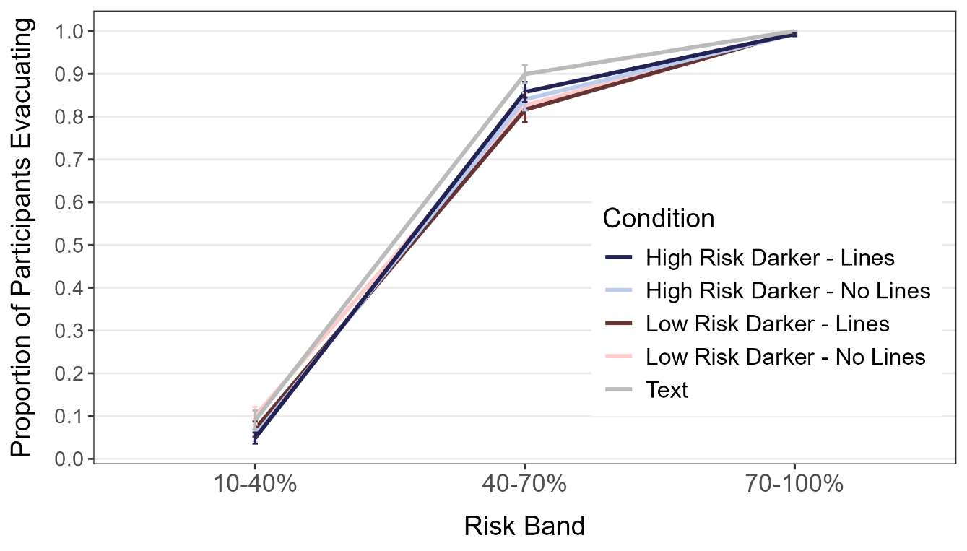
Results for the Medium-Specificity Condition in Experiment 1
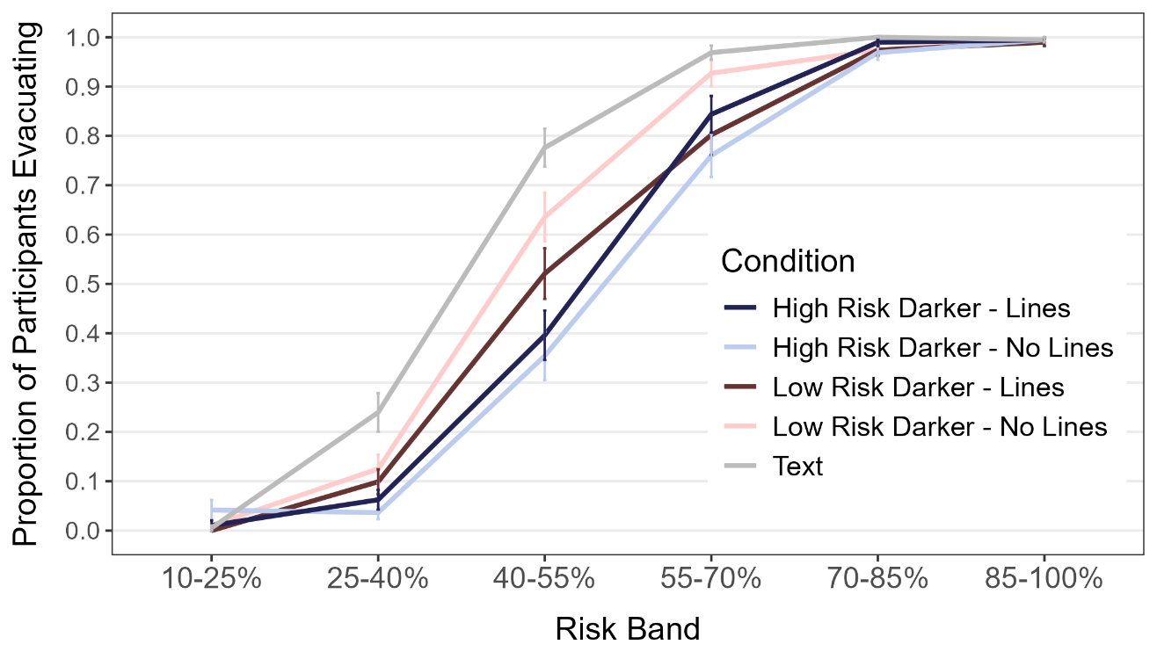
Results for the High-Specificity Condition in Experiment 1
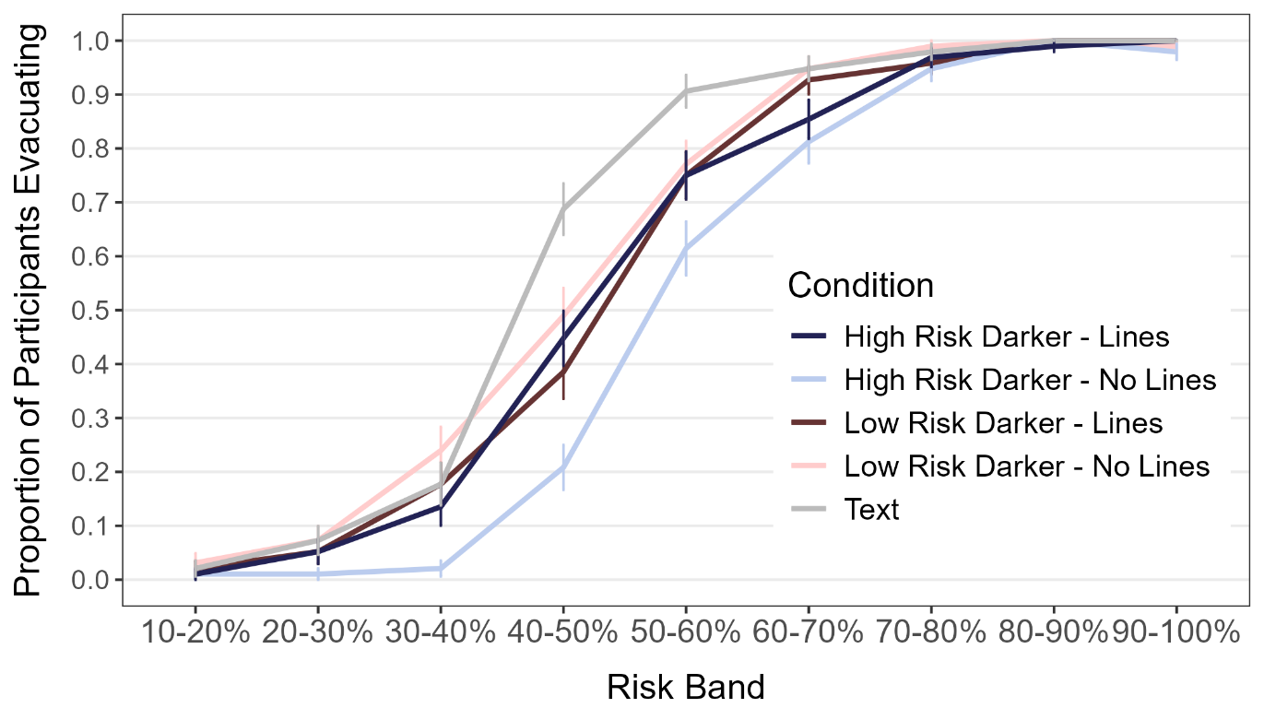

Results for the Medium-Specificity Condition in Experiment 2
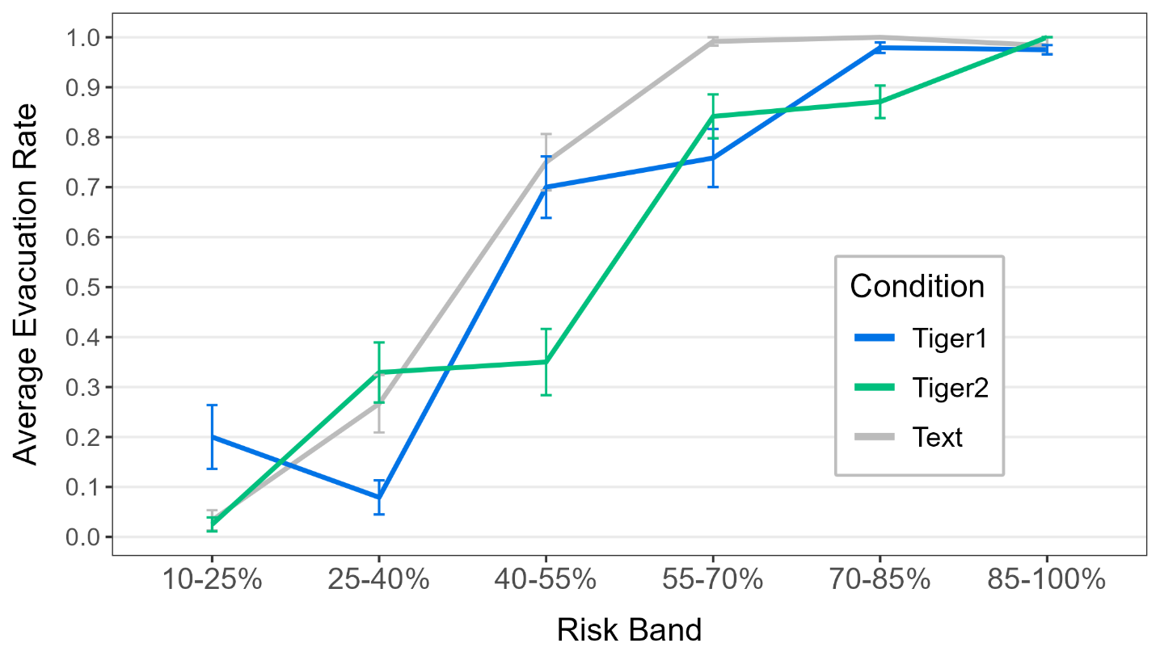
Results for the High-Specificity Condition in Experiment 2
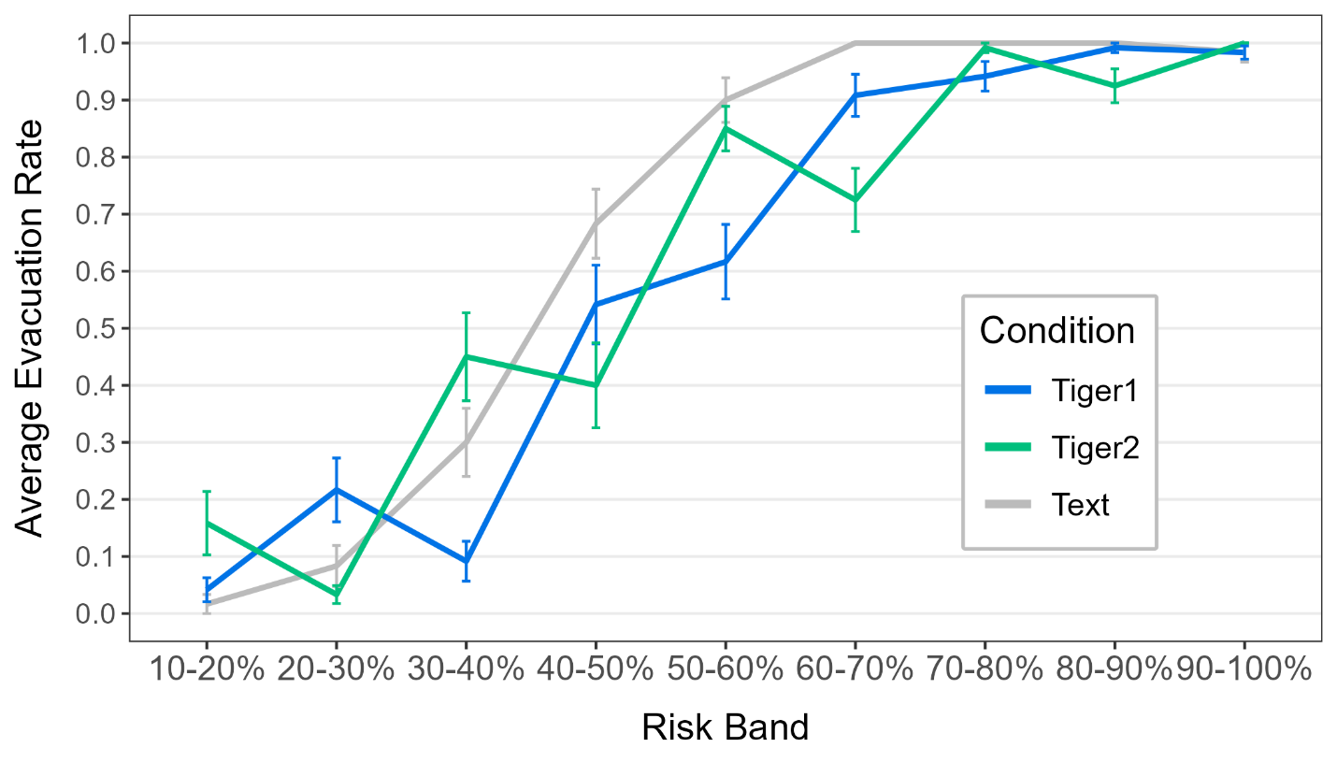

Results for the Medium-Specificity Condition in Experiment 3
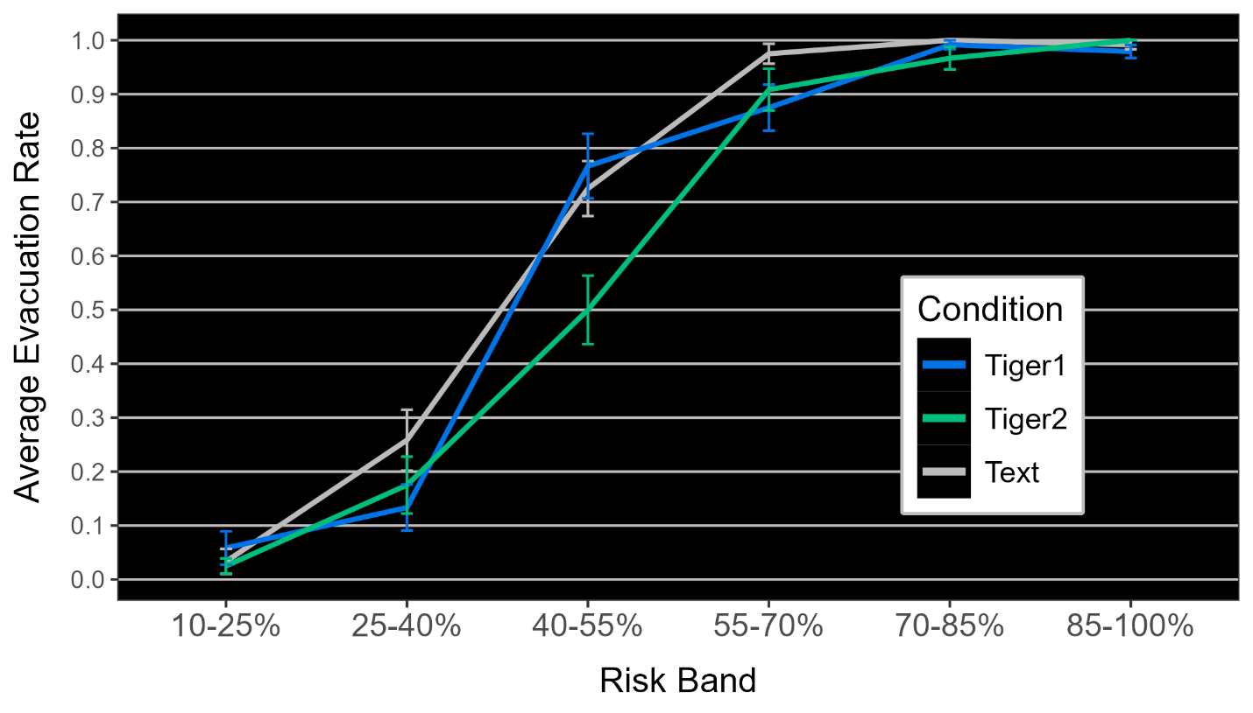

Results for the High-Specificity Condition in Experiment 3
